**2nd Grade International Studies Project Quarter 1:**

**Book Biome Project**

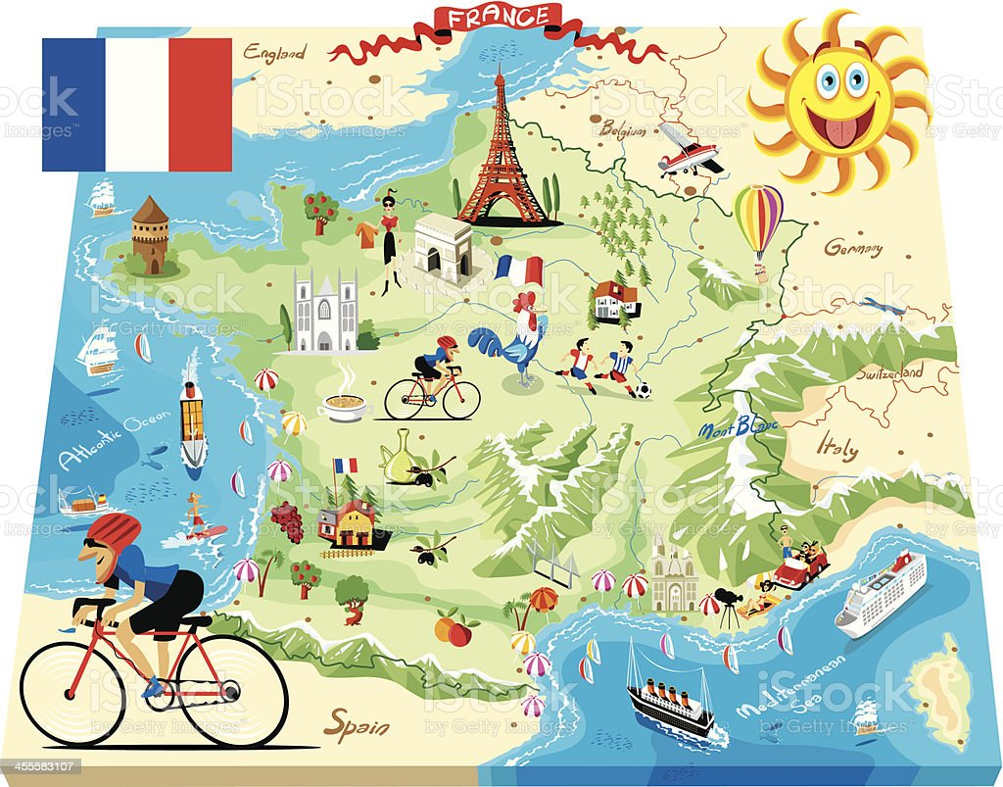

**2nd Grade Parent Acknowledgement Form**

Please read and sign the statement below; return it to your child’s homeroom teacher by **Friday, August 29, 2025.**

I have read the directions and timeline that go with this project in their entirety. **I understand that my child’s fact sheet, draft, and final Biome Book are due on the dates listed in the timeline.**

___________________________________________

Parent Signature Date

________________________ _________________

Student Signature Date

**Directions**

Welcome to our International Studies Program! This year your student is learning about the nation of France. They have spent the first quarter learning about the geography of France. For their first International Studies project, they will publish a book about the geography of France. Most of the research for this project will take place at school; however, we have included a list of websites that you can use to help your student research at home in this packet. Please see the steps below for more details:

**Step 1**

Choose **one** region of France to write your story about from the list below—

-Northern France

- Southern France

**Step 2**

Determine the character that you are going to write your story about. You must choose the character that goes with the region that you choose. See below—

-Pierre: a seven-year-old boy who lives in Northern France

- Margot: a seven-year-old girl who lives in Southern France

**Step 3**

Use the “Facts about Northern/Southern France” worksheet attached to this packet to record details that you learn about the geography of the region you chose. You should research and record the following details:

* Temperature and climate (typical weather) of the region you chose
* Landscape of the region you chose (what does the land look like—does it have mountains, flat farmland, rivers, etc.?)
* Animals that can be found in the region you choose; choose at least 2 types
* Plants that can be found in the region you choose; choose at least 2 types
* What types of things do people do for fun in this region

This fact sheet is due to your child’s homeroom teacher on **Friday, September 5, 2025.**

**Step 4**

Write your own, original story about a day in the life of either Pierre and Margot and their life in the region of France that they live in. Follow the checklist below to help you write your story. Check off the items below as you finish them—

* Give your story an interesting title. Put it on the cover.
* Write at least five pages.
* Your story should have more than one kind of complete sentence in it (telling sentences, questions, exclamatory sentences).
* Your story should be about Pierre or Margot and what a day in their life might be like—What does the land around their home look like? What is the weather like? What kinds of plants and animals are in the area they live in? What kinds of things can they do in their region of France?
* Your story should have a beginning, middle, and end as well as a problem that your character has to solve. See the sample story in this packet.
* Turn in a draft of your story to your homeroom teacher on

**Monday, September 15, 2025.**

Step 5

Once you have fixed any mistakes in the first draft of your story, write and illustrate the final version on the “Biome Book” pages that your teacher gives you. Be sure to include details about the temperature, climate, plant and animal life, and hobbies of the people in the region of France you researched. Make sure that your handwriting and illustrations are neat. Put your pages in a binder, folder, or presentation folder.

Step 6

Turn in your “Biome Book” for France by **Friday, September 26, 2025.**

**Project Timeline**

|  |  |
| --- | --- |
| **Task** | **Due Date** |
| **Turn in “Facts about Northern or Southern France” worksheet(s) to your teacher.** | **September 5, 2025** |
| **Turn in rough draft of your “Biome Book.”** | **September 15, 2025** |
| **Turn in final draft of your “Biome Book.”** | **September 26, 2025** |

Suggested Websites for Research at Home

Geography of France

[Geography of France](https://www.natgeokids.com/uk/discover/geography/countries/facts-about-france/)

[Encyclopedia Britannica Kids Geography of Northern and Southern France](https://kids.britannica.com/kids/article/France/345690)

[Video about Life in France](https://www.youtube.com/watch?v=z-kXPZg_lHo)

**Book Biome Project Rubric**

|  |  |  |  |  |
| --- | --- | --- | --- | --- |
| Category | 1 | 2 | 3 | 4 |
| Project Timeline | Students do not turn in fact sheets, drafts, and final books on time. | Students may turn in one thing on time, but the other pieces are late. | Students turn in their rough draft and final book on time. | Students turn in all parts of their project on time. |
| Biome Facts | Students are missing most key facts about their chosen island. They have one of the five facts that were requested- temperature, landscape, plants and animals, and fun activities, | Students have at least two of their five key facts about their island-temperature, landscape, plants and animals, and fun activities. | Students have three or four of the five key facts about their island-temperature, landscape, plants and animals, and fun activities. | Students have included all of their requested key facts-temperature, landscape, plants and animals, and fun activities. |
| Biome Book Completion | The story is one of the following:  -less than five pages.  -missing a title.  -missing a beginning, middle **or** end.  -does not discuss the key facts about their chosen region. | The story is one of the following:  -less than five pages  -missing a title  -does not discuss **all** key facts about their region. | The story is one of the following:  -less than five pages  -missing a title | The story has all of the elements that were asked for—title, five pages or more, beginning, middle, and end, and facts about their region. |
| Creativity and Neatness | The story has no problem that the main character has to solve. It’s written on loose-leaf paper that is not turned in inside of a binder, folder, or presentation booklet. | The story has an incomplete problem that the main character has to solve—it's only mentioned once, or the story never shares how it is solved.  -The story is not turned in inside of a folder, binder, or presentation booklet. | The story has a problem, but it is not turned in inside of a folder, binder, or presentation booklet. | The story has a unique problem and is turned in inside of a binder, folder, or presentation booklet.  The story includes cultural pieces (food, famous sayings, or clothing from the region under study). |

**Student Name: _____________________________ Score: _____/16**

** Facts about Northern or Southern France** 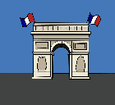

**Directions: Fill in the box for the region you chose with details about the landscape, plants, animals, and hobbies of this part of France**

|  |
| --- |
| **Northern France** |
| **Southern France** |

**Book Biome Story Ideas **

**Directions: Use these ideas to help you think up a story you could write.**

1. Your main character has a friend whose birthday is coming up. They want to give them a gift from their region of France (a plant or a pet) and set off to find the perfect thing.
2. Your main character has a friend who lives in another region of France (or another country) and sends letters. Your main character wants to write a letter back describing their home in France and what makes it special. They have to set out to find out what makes it special.
3. Your main character is going to visit a family member who lives in another region of France (or another country) and must learn how their regions are similar and different to prepare for the trip. They have a phone call with their family member where they talk about their region of France v. the region of France their family member lives in.
4. Your main character wants a pet; however, they want it to be one of the wild animals that live in the region where they live. Their friends and family must explain to them why these animals would make good pets or why they would not make good pets.

**Book Biome Sample**

**Russian Forests**

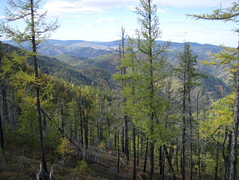

Once upon a time, deep in the Taiga of Eastern Russia, there lived a fairy named Natalia. She wore a white dress to blend in with the snow of the forests, and she had a pair of glowing white wings. All the animals of the forests came to Natalia for help with their problems.

One harsh, cold winter day an Elk came to see her. A farmer who lived in a town on the edge of the forest had taken Elk’s food so that he could feed his own hungry family. “The farmer took all of the plants on the edge of the stream that I eat at. Oh what should I do? Could you make me a meal of the pine trees in the forests,” he asked Natalia. “There are lots of pine trees here.”

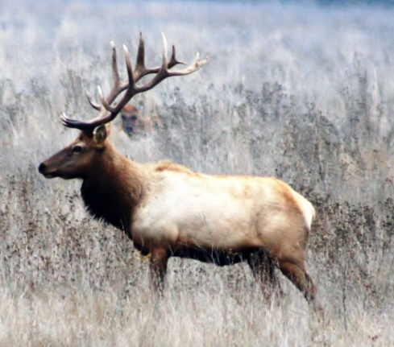 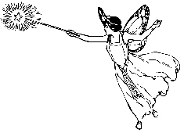

“I’m so sorry, Elk," Natalia said, “but you cannot eat the pine trees in the forest. They have no leaves, only pointy pine needles that never fall down.”

Elk began to cry because of how hungry he was. “What will I eat?” he asked. Natalia thought and thought. Suddenly, an idea came to her.

“You can try to eat the moss and mushrooms that sometimes grow on the forest floor,” Natalia told Elk.

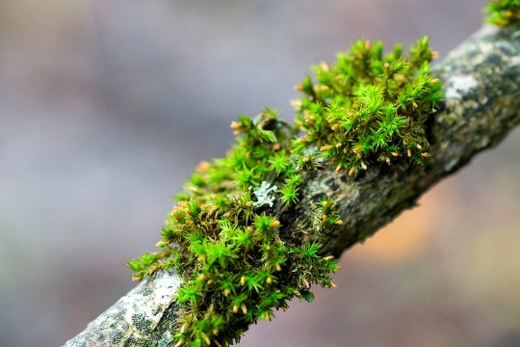 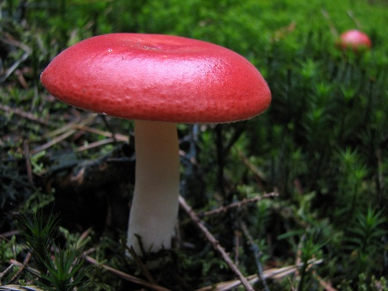

Siberian moss

Elk was uncertain at first, but he took a small bite of the moss. He told Natalia that it didn’t taste like the plants by the stream that he was used to, but it was something. He thanked her for all of her help and walked away chomping on bits of moss as he went.

Days later in the middle of heavy snow, a tiger came to see Natalia.

“Elk told me that you are very helpful,” Tiger said to Natalia.

“I try to be the best friend I can to everyone,” Natalia said. “How can I help; do you need to know what food to eat?”

“No,” Tiger said. “I am able to eat the elk, bear, and wild boar that roam the forest. When it is very cold and there are fewer animals, I can eat smaller prey. My problem is that I have no friends to play with in the snow. Everyone is afraid of me.”

Natalia felt terrible hearing Tiger say he had no friends. She decided right then and there to help him find some...

**Please note: This is not a complete story like the ones students should turn in; rather, it is a sample of the type of writing students could do to create their story for their country. A second sample is given below.**

**Book Biome Sample Story 2**

**Moscow**

**Sofia is an eight-year-old girl who lives in Moscow. Moscow is a city in the**