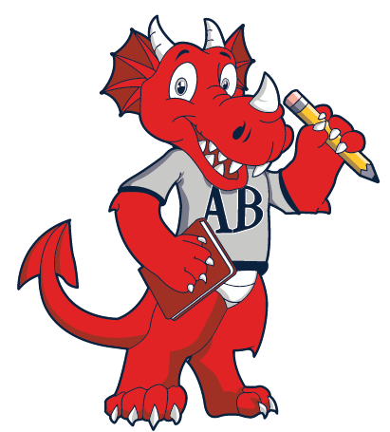

A.B. Hill Elementary School Family Engagement Plan
2024-2025
The A.B. Hill School Family Engagement Plan was jointly developed with parents and has set forth expectation for parental involvement and to define the school's commitment to providing parents with the necessary information and skills to help their children achieve academic excellence and success.

A.B. Hill Elementary School's parents will act as advisors, resource persons, and coordinators in the following ways:
- Supporting our school's efforts to maintain a safe and respectful environment
- Encouraging their child to solve conflicts peacefully
- Supporting our school's efforts to help their child achieve academically
- Assisting their child with homework and school related projects
- Expressing ideas, concerns, and suggestions to teachers and school administrators
- Providing frequent and meaningful attention to help their child reach their full potential in school and in life
- Maintaining ongoing communication (parent/teacher conferences, open house, school related events)
- Actively participating parent workshops
- Responding to memos, surveys and questionnaires expressing their ideas and/or concerns
- Using their resources to support A.B.Hill instructional program
- Becoming A.B. HiI1 Elementary School supporters and advocates within their community

Title I/Schoo1 Commitment
A.B. Hill Elementary School will encourage families to become meaningfully engaged in their child's education b7 doing the following:

- Inviting all parents/legal guardians to the annual meetings that will be held during the school year to inform them of ESEA and Title I requirements, the school's participation in Title I, and the rights of parents to be involved in the school
- Conducting regular and flexible number of parent meetings (morning, afternoon, and evening), to keep parents informed of current events and issues, curriculum, academic assessments, proficiency levels, progress reports, and parent/teacher conferences
- Involving parents in organized and ongoing development and future revisions of the School Improvement Plan, Family Engagement Plan, Parent/School Compact and other documents and programs relating to their child's academic instruction
- Providing written and verbal communication in their primary language
- Encouraging parental involvement by offering parent training and workshops, based on surveyed parental needs
- Providing appropriate resources to support during and after school learning
- Provide timely information about parent programs, opportunities for regular meetings and training, as well as family services to improve the parents' ability to help with their child's education

- Provide opportunities for parents to participate in an organized, ongoing, and timely process to assist in the planning and reviewing programs
- Distributing Parent/Student Handbooks, Family Engagement Plans and Parent/School Compacts (which
has been jointly developed with parents) and acquiring appropriate signatures
- Encouraging parents to observe and volunteer in the school's programs and classrooms as well as informing parents of their right to be involved.
- Providing parents with ongoing, current student information and progress reports and ensuring that they are invited to Annual meetings
- Build capacity for parent and community involvement
- Listening to those we serve, our parents, students and stakeholders, to help gain insight into the hearts, minds and cultures of our families and use this information to develop and administer programs and policies that positively affect our student's school experience

A.B. Hill Elementary School will notify parents of this plan in an understandable and uniform format, and to the extent practicable, provide it in a language that parents can understand. This plan is made available to the local community and updated periodically to meet the changing needs of parents and the school. Parents are encouraged to take an active role in school improvement. By continuing to work collaboratively to improve our school, we can make a difference at A.B. Hill Elementary School.
Shelby County Schools offers educational and employment opportunities without regard to race, religion,
sex, creed, age, disability, national origin, or genetic information.

