**Chapter 7 – Chemical Names & Formulas**

1. Systematic Chemical Names
2. The method for naming compounds is determined by the

**International Union of Pure & Applied Chemistry.**

1. Chemical formulas indicate two types of information:

1. The specific _______________ that compose the compound

2. The _______________ ____________ of __________

3. Pay attention to any parentheses used in the formula!

Al2(SO4)3

1. Monatomic Ions
2. Monatomic ions are made of only one type of atom
3. **Monatomic ion** – ions ( ____________ _______________)

formed from a ___________ atom

a. **Cations** - _______________-charged ions; ________

usually form these types of ions

b. **Anions** - _______________-charged ions; ________

usually form these types of ions

2. Elements in groups 1, 2, and 13-17 form ions with

predictable charges:

|  |  |  |  |  |  |  |  |  |
| --- | --- | --- | --- | --- | --- | --- | --- | --- |
| **Group**  **#** | 1 | 2 | 13 | 14 | 15 | 16 | 17 | 18* |
| **Possible**  **Charge** |  |  |  |  |  |  |  |  |

**MEMORIZE** this trend…you should be able to look at a periodic table and predict the charges from these groups.

1. Naming Monatomic Ions

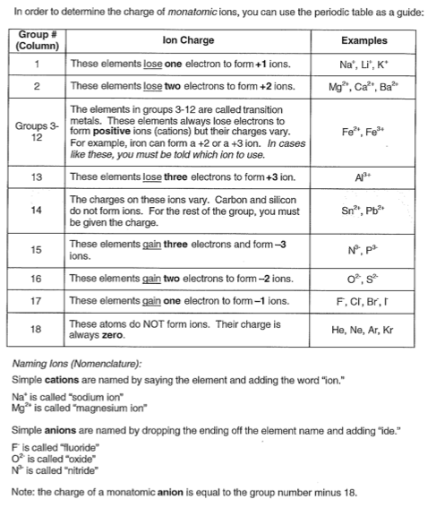

1. Ionic Compounds

A. Binary Ionic Compounds

1. **Binary compounds** are composed of only ___ elements;

usually a __________ and a _______________.

1. Writing Binary Ionic Compound Formulas

a. The __________ ion is always written **first**

b. The __________ ion is always written **second**

c. To predict the correct formula, use the **criss-cross method**

1. Write the symbol and the charge of the (+) ion

2. Write the symbol and charge of the (-) ion

3. Make the value of the charge of the (+) ion the (-) ion’s subscript…make the value of the charge of the

(-) ion the (+) ion’s subscript (**all subscripts are positive!**)

** This “**criss-cross method**” insures the overall charge of the compound is **zero!**

**NOTE:** Simplify/reduce your subscripts to the lowest ratio!

d. Metals from Groups 3-12 (and some from Group 14) have

multiple charges. The *Roman numeral after their name* will

indicate the charge of the metal. (This is called the *Stock*

*system* name.)

e. Examples

1. barium fluoride 2. sodium phosphide

3. aluminum phosphide 4. copper (II) bromide

5. iron (III) nitride 6. tin (IV) selenide

3. Naming Binary Ionic Compounds

a. If the metal in the compound has a fixed ionic charge

(usually from Group 1, 2, or 13), the compound will be

named in the following way:

1. The metal is named first with _____ ____________to the name.
2. The nonmetal is named second by dropping the ending and adding _______

**NOTE:** Three other metals that also use this method of naming are cadmium (Cd2+), silver (Ag+), and

zinc (Zn2+)

b. Examples

1. KCl

2. Ag2S

3. Ba3P2

4. CdO

c. Naming Binary Ionic Compounds with Transition Metals…

we’ll be using the ***Stock System*** *to name the meta*l…

You have to include a Roman numeral (in parenthesis) after the metal’s name

(# of metal atoms)( x) + (# of nonmetal atoms)(charge of nonmetal) = 0

↑

charge

of metal

(Roman Numeral)

1. Fe2O3 2. PbS2 3. Hg2I2

B. Ternary Ionic Compounds

1. **Ternary compounds** are composed of ____ or _______

elements

2. If the compound is ionic, there will be at least one

**polyatomic ion** present in the formula

a. **Polyatomic ion** - groups of _____ or

________ atoms covalently bonded together AND possessing a __________

b. These are listed on your Ionic Chart (handout)

3. Writing Ternary Formulas

a. copper (II) nitrate

b. lithium sulfate

c. ammonium sulfite

d. magnesium carbonate

4. Naming Ternary Ionic Compounds

a. In naming ternary compounds, we follow the same procedure as for binary ionic compounds, EXCEPT___________ change the ending of the polyatomic ion’s name!

b. Examples (Naming)

1. NaNO2

2. NH4Cl

3. AgClO2

(# of metal atoms)( x) + (# of polyatomic ions)(charge of polyatomic ion) = 0

↑

charge

of metal

(Roman Numeral)

4. Cu3(PO4)2 [use Stock System name]

5. Hg2SO4 [use Stock System name]

1. Binary Molecular Compounds
2. Binary **molecular** compounds will be composed of either…
3. _____ _______________

OR

1. A _______________ and a _______________
2. Naming Binary Molecular Compounds

1. Name the first element by simply writing the name of the

element _______________ ________ ______________.

2. Name the second element by dropping the ending & adding

_______

3. The number of atoms of *each* element must be indicated by

placing a ________ prefix in front of the name of the element

1. The following Greek prefixes **must be MEMORIZED!!**
2. If you only have one atom of the first element, you only write the name; ______ ______ use the prefix

________!!!

1. The second element ________ has a prefix (no matter what)!!!
2. When certain vowels appear next to each other (“oo” or “ao”), the vowel from the Greek prefix is dropped for better pronunciation

4. **Diatomic Molecule** – two _______________ atoms

_______________ bonded together

a. There are 7 common diatomic molecules you should

memorize:

b. There are three common ways to name these

molecules:

**The Diatomic Molecule Song\***

(to the tune of **The Barney Song**)

Atoms in two

Stuck like glue

Diatomic molecules

This is for YOU

There is hydrogen, nitrogen, oxygen & more

Fluorine, chlorine, bromine, iodine are the other four!

*Written by Jan MacDonald

East Anchorage High School

5. Examples

a. BCl3

b. PI5

c. CO

d. SO2

1. N2O5
2. IF7
3. O2
4. Writing Binary Molecular Formulas

1. The Greek prefixes will tell you how many atoms of each

element you’ll have

2. The numbers will be written after the element’s symbol and

slightly lower…they are known as **subscripts**

1. Examples
2. carbon tetrachloride
3. dinitrogen monoxide
4. dihydrogen monoxide
5. sulfur hexafluoride
6. molecular hydrogen
7. dichlorine monoxide
8. nitrogen trihydride
9. silicon dioxide