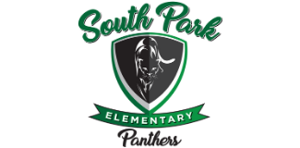

Dear Parent or Guardian,

Each year the Tennessee Department of Education examines schools’ performance across several different indicators to provide an overall look at how schools are serving the needs of all students. The department of education included the following indicators in its analysis of school accountability:
- Student achievement
- Student growth
- English learner proficiency exam (ELPA)
- Chronic absenteeism
- Ready graduate (high school only)
- Graduation rate (high school only)

More information on each of these indicators and the data used to define them can be found in the 2023-2024 Federal Accountability Protocol. Under the federal Every Student Succeeds Act (ESSA), the department is required to use the school accountability results to identify those schools with the lowest performance across student groups (e.g., individual racial/ethnic student groups, students with disabilities, economically disadvantaged, and English learners). These schools will receive additional supports from the department.

We are writing to inform you that South Park Elementary is identified for Targeted Support and Improvement (TSI) Designation as required by ESSA and the U.S. Department of Education during the 2024-25 school year.

Our school is working hard with the district and the Tennessee Department of Education to increase student performance by providing K-5 Intervention, During school tutoring for grade 4 and After-school tutoring for grades K-5. We provide small and whole group reteaching on designated days. In addition, teachers meet with each student to inform them of their academic performance on formative assessment. Teachers and administrators meet weekly to discuss data and strategies to improve academic success for students and school. We encourage you to help by participating in the development and implementation of our school improvement plan and/or to attend family engagement meetings.

Sincerely,
Felicia Strickland
Principal

