**Chapter 3 – Atoms: The Building Blocks of Matter**

I. The Atom: From Philosophical Idea to Scientific Theory

# Performance-Based Objective #1 (Let’s Annotate!)

**SWBAT** compare and contrast the historical models of the atom (Dalton, Thomson, Rutherford) **IOT** illustrate how advances in technology and data collection lead to modifications and improvements to the current understanding of atomic theory**.**

1. The particle theory of matter was supported as early as _____ BC

by the Greek thinker (philosopher) ____________. He called

nature’s basic particle an ______, based on the Greek word

meaning “indivisible.”

B. Three Basic Laws About Matter

1. In the 1790s, advances in technology (improved balances)

allowed chemists to study how compounds reacted.

2. Three Laws (Evidence for Atomic Theory)…

a. **Law of Conservation of Mass** – mass is neither _________nor _______________ during ordinary chemical reactions or physical changes.

b. **Law of Definite Proportions** – a compound

contains the _____ __________ in exactly the same _____________ by mass regardless of sample size

or source of the compound.

c. **Law of Multiple Proportions** - if two or more compounds are composed of the same two elements, then the _____ of the masses of the

**________** element combined with a certain mass of the _______ element is a ratio of _______ ________ ___________

B. Compounds Contain Atoms in Whole-Number Ratios

1. John Dalton (1776-1884) - published his Atomic Theory in 1808

a. All matter is composed of _______________ __________ particles called _________

b. Atoms of a given element are _______________ in

________, _______, and other properties.

Atoms of _______________ __________ differ in these properties.

c. Atoms cannot be _______________, ____________,

or _______________.

d. Atoms of different elements combine in simple _________ ___________ ____________ to form chemical _____________

e. In a chemical reaction, atoms are _____________,

_______________, or __________________

2. **Dalton’s Atomic Theory** easily explains the **Laws of**

**Conservation, Definite Proportions, and Multiple**

**Proportions of Mass**!

C. Atoms **CAN** be subdivided into smaller particles!

Two points of Dalton’s theory have been modified due to

technological advancements:

1. Atoms **CAN** be divided into smaller particles (protons,

neutrons, and electrons)

2. Atoms of the same element **CAN** have slightly

**DIFFERENT** masses

II. The Structure of the Atom

A. **Atom –** smallest particle of an _______________ that retains the

_______________ _______________ of that element.

B. Atoms Contain Positive and Negative Particles

1. Cathode Ray Tube (Sir William Crookes - 1879)

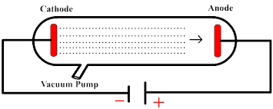

* NOTE: When an electric or magnetic field was placed near the tube, the particles were affected in a strange way!

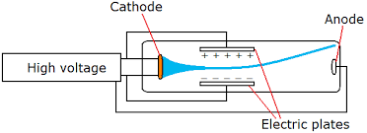

* These experiments led to the hypothesis that the particles in a cathode

rays are _____________ charged.

2. John Joseph (“J. J.”) Thomson (1897)

1. Measured the ratio of the ________ of the cathode-ray particles to their _____ .
2. Concluded that all cathode rays are composed of

__________ __________ charged particles, which were named __________.

3. Robert Millikan (1909) – measured the __________ of the

electron (“Oil Drop Experiment”)

4. Since matter is neutral, there has to be positive material in

the atom to counteract the electrons

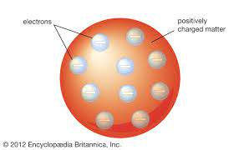* JJ Thomson proposed the Plum Pudding Model in 1904…but we now know it was **INCORRECT!!!**

C. Atoms have Small, Dense, Positively Charged Nuclei

1. The Gold Foil Experiment (Ernest Rutherford - 1911)

a. Experimental Design

1. A thin, gold foil was bombarded with ______ particles (positively-charged; four times the mass of the hydrogen atom)

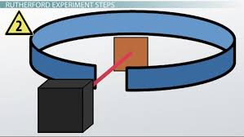

2. The foil was

surrounded by a

screen that would

detect where the

alpha particles

would hit once they

passed through the

foil

b. The Results

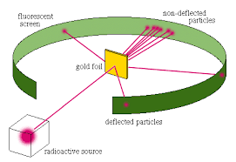

1. Most of the alpha

particles went straight

through the foil or were

slightly deflected (this

was expected)

2. **HOWEVER** they were surprised when about 1 of 8000 particles deflected __________ toward

the source.

c. Rutherford’s Hypothesis

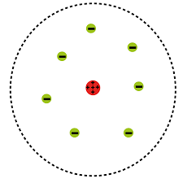

1. Small, densely packed bundles of matter with a

__________ charge must have caused the

backwards deflections.

2. Rutherford used the term __________ to

describe each bundle of matter.

3. Rutherford refined his model by including

positively charged particles in nucleus called

protons

4. For every proton an atom has in its nucleus,

the same number of _______ surrounds the nucleus

D. A Nucleus contains Protons and Neutrons

|  |  |  |  |  |  |
| --- | --- | --- | --- | --- | --- |
| **Particle** | **Symbols** | **Relative Electric Charge** | **Mass**  **Number** | **Relative**  **Mass**  **(u*)** | **Actual Mass**  **(kg)** |
| Electron |  |  |  | 0.0005486 | 9.109 x 10-31 |
| Proton |  |  |  | 1.007276 | 1.673 x 10-27 |
| Neutron |  |  |  | 1.008665 | 1.675 x 10-27 |

* u = unified atomic mass unit or “amu”

III. Counting Atoms

**Performance-Based Objective #2 (Let’s Annotate!)**

**SWBAT** apply an understanding of isotopes, atomic number, and mass number **IOT** determine the number of protons, neutrons, and electrons in an isotope**.**

A. All atoms of an element must have the same number of protons but

not neutrons

1. **Atomic Number –** number of ___________ in the nucleus

a. Every element has a **DIFFERENT** atomic number. This identifies the element!

b. Found on the periodic table...in each element block near the symbol

c. In a neutral atom, there will be the ________ number of ____________ as there are ______________

1. **Isotopes** – atoms of the __________ _______________

that have _______________ masses.

1. Isotopes of Hydrogen

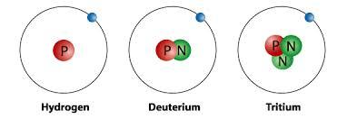

|  |  |  |  |
| --- | --- | --- | --- |
| **# p+** |  |  |  |
| **# n0** |  |  |  |
| **p+ & n0** |  |  |  |

1. The atoms in any sample of an element most likely

will have a mixture of several isotopes in various

proportions.

3. **Mass Number** – total number of _____________ and

_____________ that make up the nucleus of an isotope.

1. MUST be given to you!!! NOT on the periodic table!!!

b. Isotopes have the same ____________ ___________

**BUT** different __________ ___________!

c. Although isotopes have different masses, they do NOT have different chemical behavior

4. Identifying Isotopes

a. Nuclear Symbol

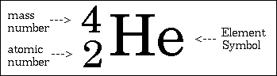

1. Hyphen Notation

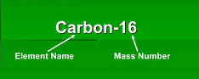

c. Using either notation, one can determine the number of protons, neutrons, and electrons the isotope possesses

1. # protons = atomic number (from periodic table) = # electrons

2. # neutrons =

d. Examples

|  |  |  |  |  |
| --- | --- | --- | --- | --- |
| **Nuclear Symbol** | **Hyphen**  **Notation** | **Number of protons** | **Number of neutrons** | **Number of electrons** |
| chlorine-35.png |  |  |  |  |
| Iodine-131.jpg |  |  |  |  |
|  | Uranium-235 |  |  |  |
|  |  | 20 | 21 | 20 |

B. Atomic mass is a **relative** measure

1. Carbon-12 (6 protons/6 neutrons) was assigned a mass of

12 **atomic** **mass units** (**amu**s)

2. One **atomic mass unit** (**amu**) is defined as _____________

the mass of a _______________ atom

3. The mass of all other isotopes were determined by

comparing their mass to that of carbon-12

4. One amu is nearly, but not exactly, equal to one proton or

one neutron

C. Average atomic mass (or average atomic weight) is a **weighted**

value

1. Scientists determine the average atomic mass by

determining the abundance of each isotope and then

factoring in the mass of the isotope.

1. Most naturally-occurring elements have at least two

isotopes.

D. A **relative** mass scale makes counting atoms possible

1. The Mole

a. A **mole** is the amount of substance that contains as

many _______________ as there are ____________

in exactly 12 grams of ________________.

b. The mole is a ________________ unit (a word that

indicates a number)

2. Avogadro’s Number

a. The number of particles in a mole has been

experimentally determined in a number of ways.

b. The best modern value is

6.02214179 x 1023

which means there are 6.02214179 x 1023 atoms of

carbon-12 in a 12 gram sample.

c. This number is called “Avogadro’s Number” in honor

of _______________ _________________...

the Italian scientist whose ideas were crucial in

explaining the relationship between mass and

numbers of atoms.

d. This number is usually rounded to…