

Math Weekly Lesson Preparation Guide

Teacher Name: Kimberly West | Grade: 11th /12th Precalculus
Week of: April 7th thru April 11th | Lesson: Fundamental Trigonometric Identities

Purpose: The Weekly Lesson Preparation Guide is to provide a structure that encourages teachers to think through and internalize the daily/weekly instructional expectations.
Planning Questions
- Which specific Tennessee standard(s) are being addressed in this lesson? What is the focus of this lesson? What will the lesson objective be for each day? | P.G.TI.A.1 Apply trigonometric identities to verify identities and solve equations. Identities include: Pythagorean, reciprocal, quotient, sum/difference, double-angle, and half-angle  Vocabulary  *Identities  *Cofunction Identities  *Reciprocal  OBJECTIVE: I can use fundamental identities to evaluate trigonometric expressions.  I can use fundamental identities to simplify trigonometric expressions.
Modeling:  - What specific tasks/problems will you use to reveal understanding of the grade-level standard(s)? (refer to the Instructional Focus Document Evidence of Learning Statements | 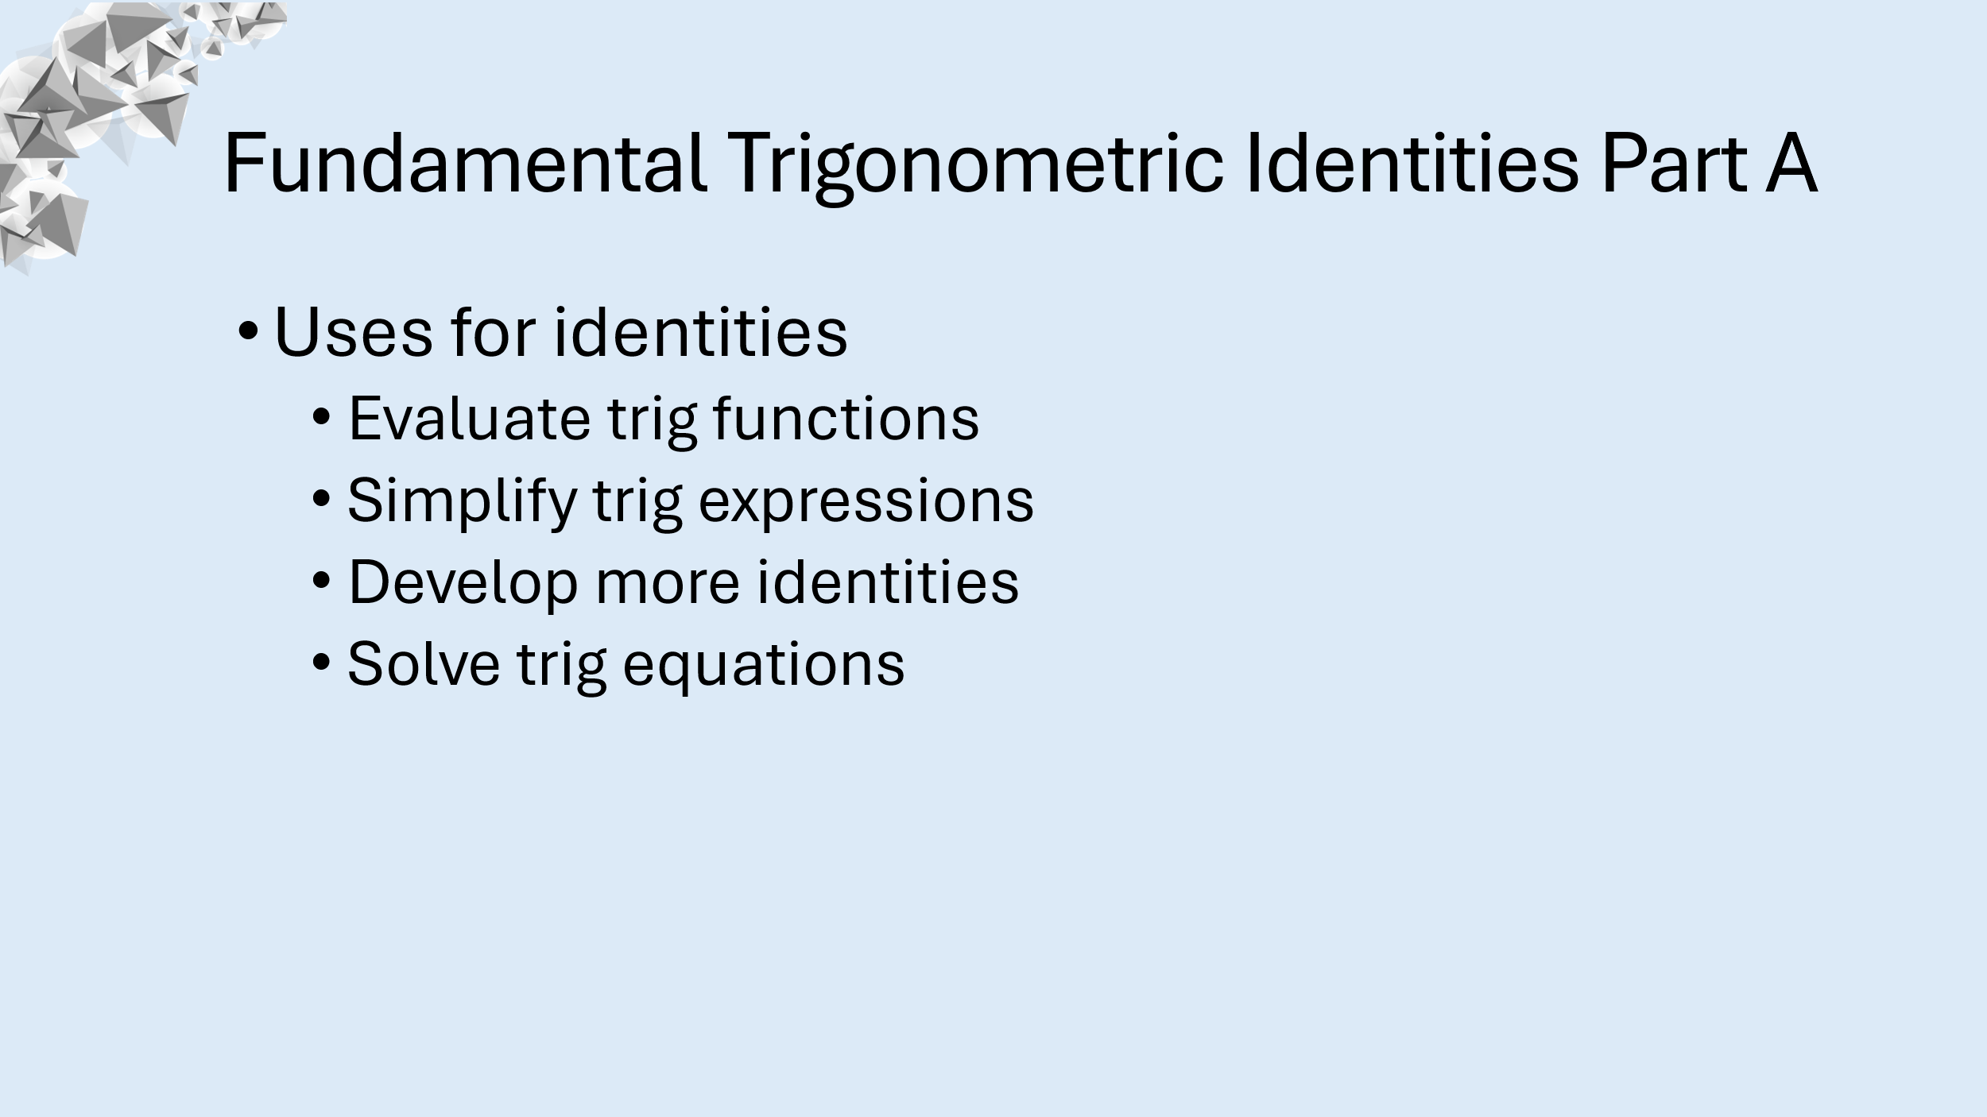  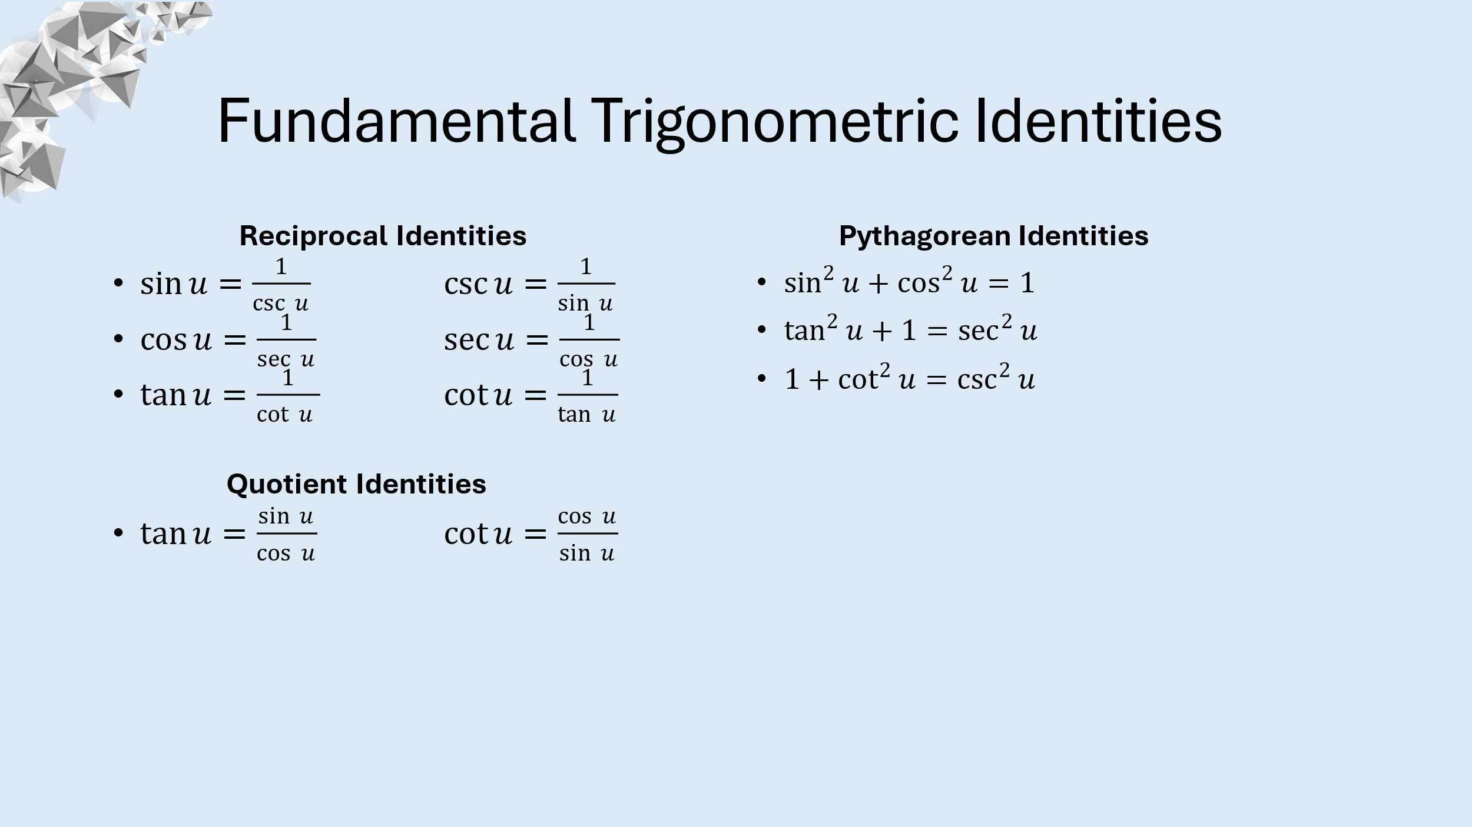  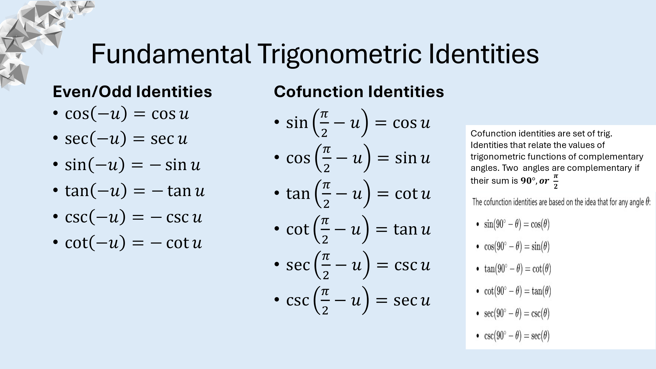  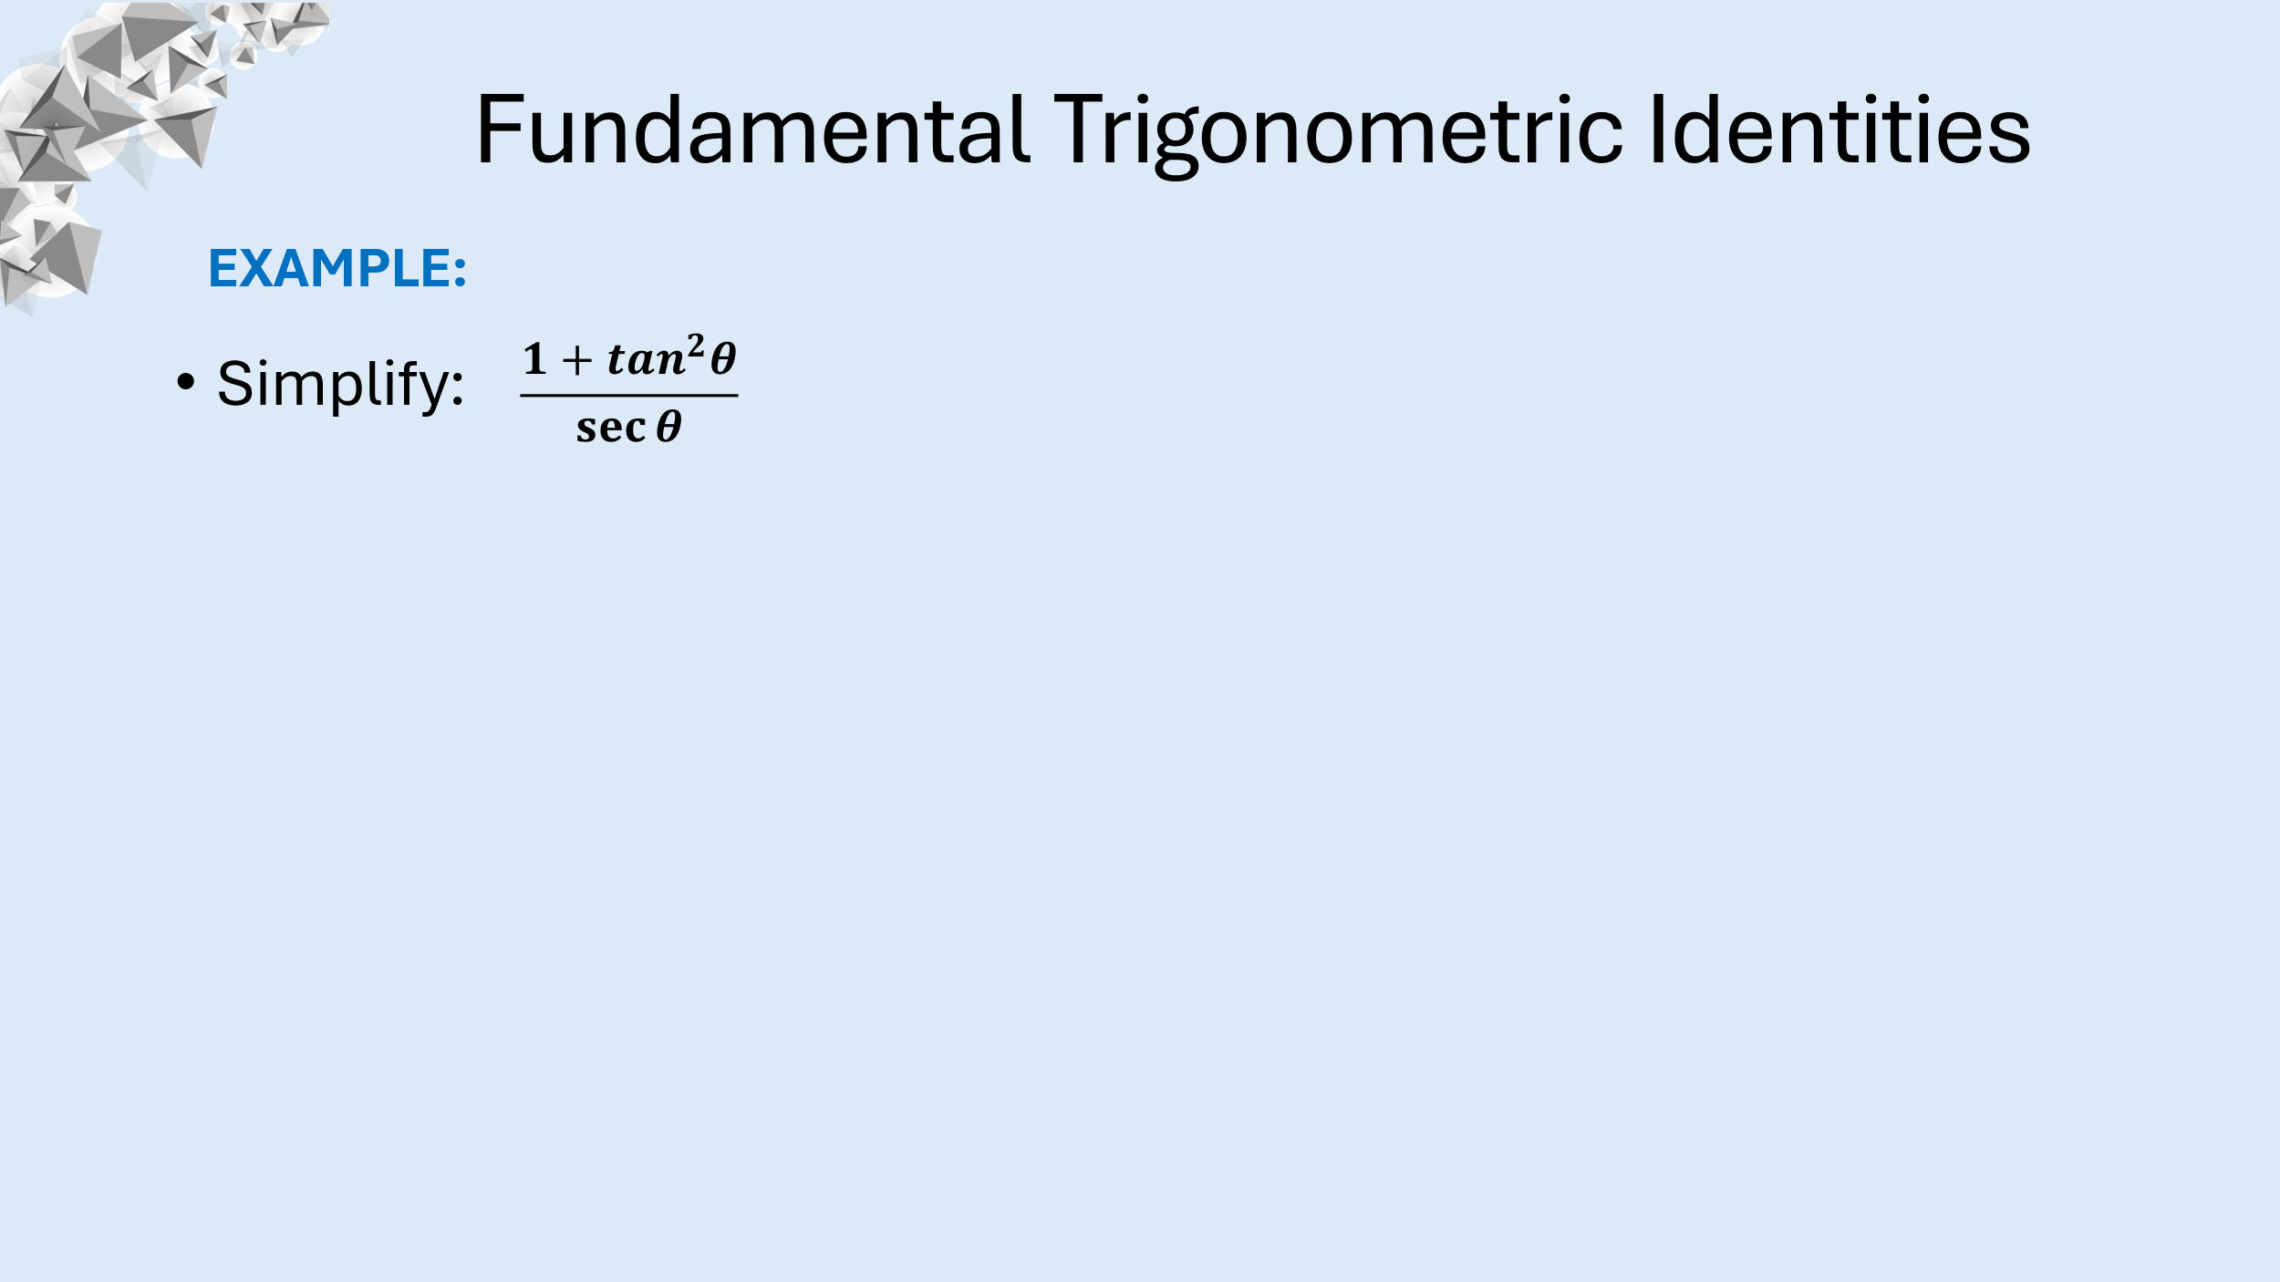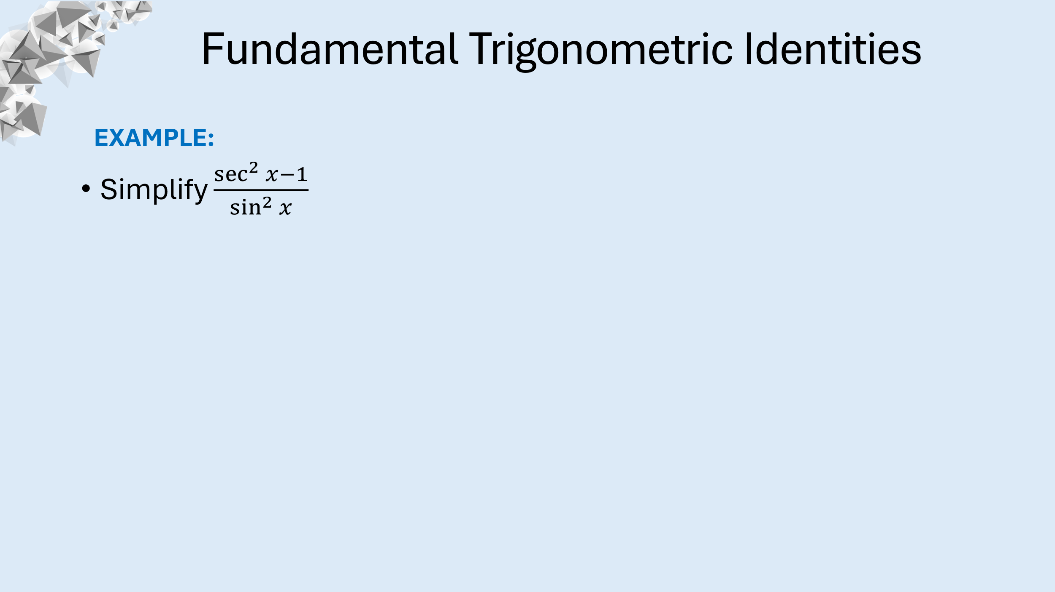  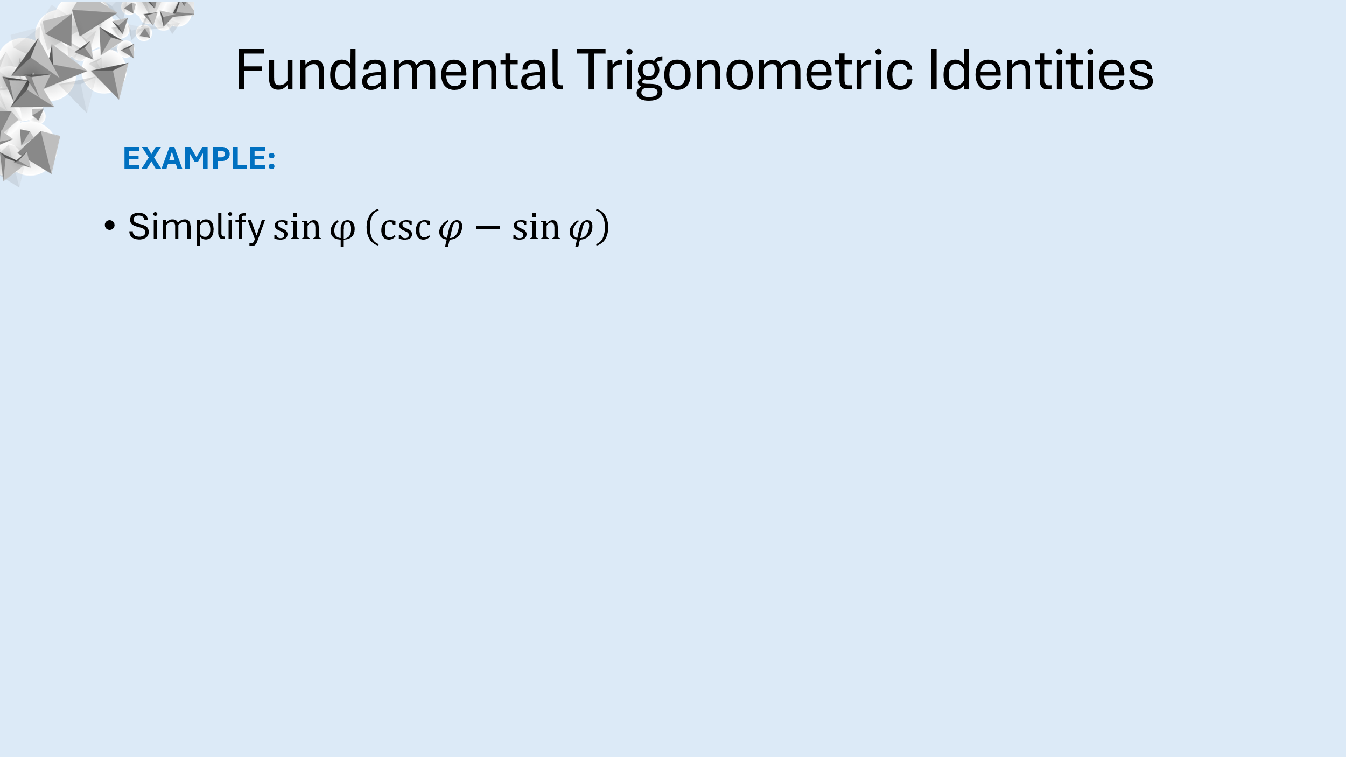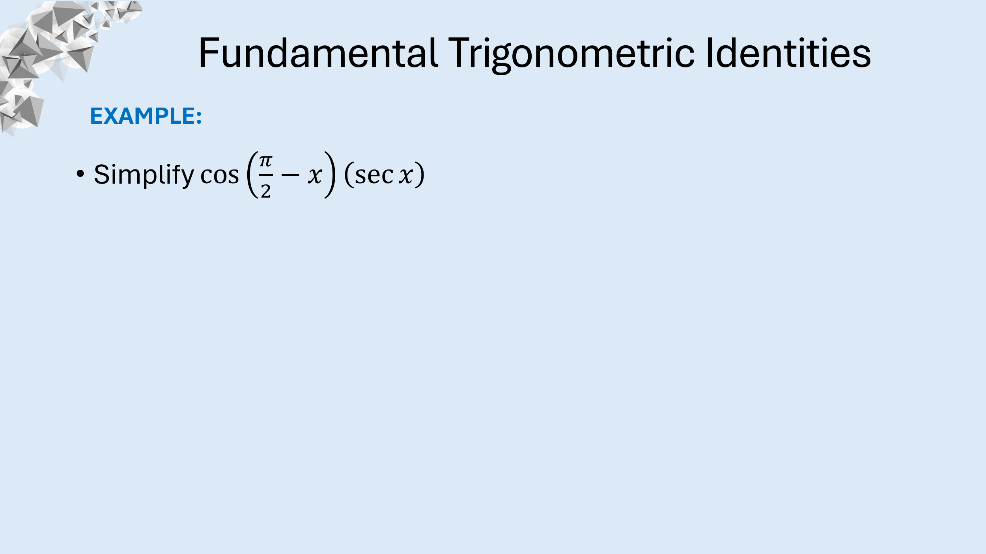
- Practice (student task) | *Selective Practice Problems: Board-work/ Handouts/Quizizz/Khan Academy  *Look and listen for proper steps and vocabulary used to explain each step in the problem-solving process
Additional Considerations
If your lesson contains homework, how will you utilize the work? Will you need to send scaffolding notes home? Is there a strategy you can use to maximize homework? | Homework will be utilized by:  Align with Learning Objectives: Ensure that homework directly relates to the concepts taught in class, allowing students to apply their learning.  Variety of Tasks: Include different types of problems (e.g., practice, application, extension) to cater to various levels of understanding and to reinforce the concept from multiple angles.  Scaffolded Problems: Start with easier problems and gradually increase difficulty. This helps build confidence and understanding before tackling more complex tasks.  Extension Challenges: Include a few challenging problems that encourage critical thinking and exploration beyond the basic concepts.

