5th Grade International Studies Project Quarter 1:

Book Biome Project

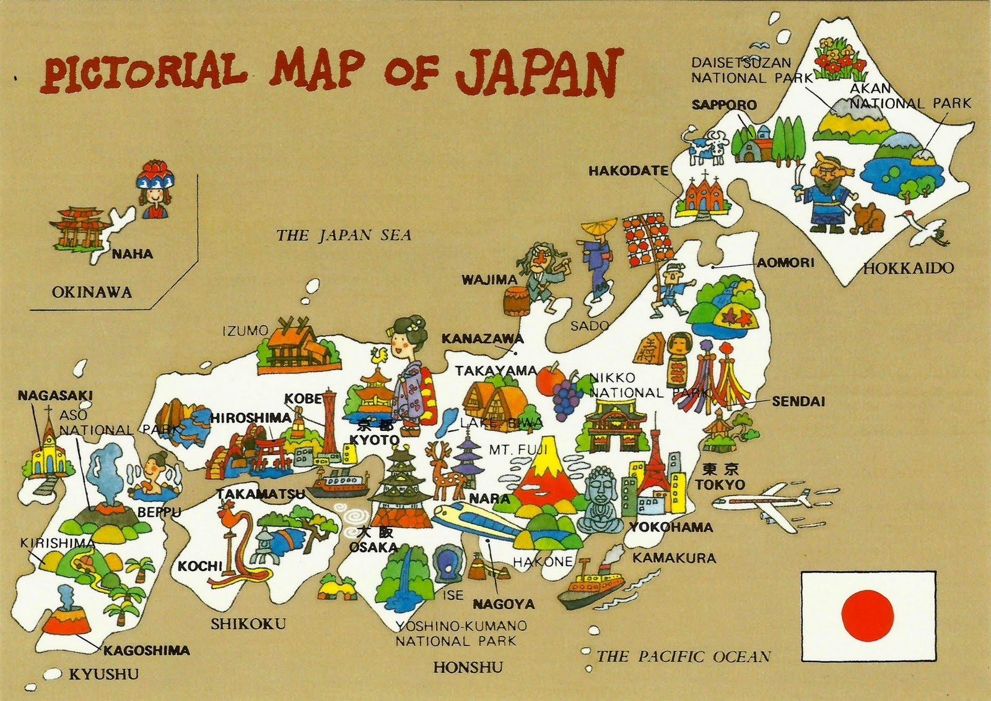

**5th Grade Parent Acknowledgement Form**

Please read and sign the statement below; return it to your child’s homeroom teacher by

**Friday, August 29, 2025**.

I have read the directions and timeline that go with this project in their entirety. I **understand that my child’s fact sheet, draft, and final Biome Book are due on the dates listed in the timeline.**

_____________________________________

Parent Signature Date

______________________ _________

Student Signature Date

**Directions**

Our students have spent the first quarter learning about the geography of Japan. For their first International Studies project, they will publish a book about the geography of one of the major islands of Japan. Most of the research for this project will be completed at school, but we have included a list of websites that you can use to do research with your **student at home! Please see the steps below for more details:**

**Step 1**

Choose one of the main islands of Japan to write your story about; choose from the list below—

-Hokkaido

- Honshu

-Kyushu

**-Shikoku**

**Step 2**

Brainstorm a story from the point of view of someone who lives on the island that you chose.

**Step 3 (to be completed both at home and at school):**

Use the “**Facts about ________________ island, Japan” worksheet** attached to this packet to record details that you learn about the geography of the island you chose. You should research and record the following details:

* Temperature and climate (typical weather) of the region you chose
* Landscape of the region you chose (what does the land look like—does it have mountains, flat farmland, rivers, etc.?)
* Animals that can be found in the region you choose; choose at least 2 types
* Plants that can be found in the region you choose; choose at least 2 types
* What types of things do people do for fun in this region

This fact sheet is due to your child’s homeroom teacher on **Friday, September 5, 2025.**

**Step 4 (to be completed both at home and at school):**

Write your own, original story about a day in the life of your main character; it should cover their life in the region of Japan that they live in. Follow the checklist below to help you write your story. Check off the items below as you finish them—

* Give your story an interesting title. Put it on the cover.
* Write at least five pages.
* Your story should have more than one kind of complete sentence in it (telling sentences, questions, exclamatory sentences).
* Your story should be about a day in the life of your main character and what it might be like—What does the land around their home look like? What is the weather like? What kinds of plants and animals are in the area they live in? What kinds of things can they do in their region of Japan?
* Your story should be written entirely from the point of view of your main character.
* Your story should have a beginning, middle, and end as well as a problem that your character has to solve.
* Turn in a draft of your story to your homeroom teacher on

**Monday, September 15, 2025.**

**Step 5**

Once you have fixed any mistakes in the first draft of your story, write and illustrate the final version in the “Biome Book” pages that your teacher gives you. Be sure to include details about the temperature, climate, plant and animal life, and hobbies of the people in the region of Japan you researched. Make sure that your handwriting and illustrations are neat. Put those pages inside of a binder, folder, or presentation folder.

**Step 6**

Turn in your “Biome Book” for Japan by

**Friday, September 26, 2025.**

**Project Timeline**

|  |  |
| --- | --- |
| **Task** | **Due Date** |
| **Turn in “Facts about ________________ island, Japan” worksheet(s) to your teacher.** | **September 5, 2025** |
| **Turn in rough draft of your “Biome Book.”** | **September 15, 2025** |
| **Turn in final draft of your “Biome Book.”** | **September 26, 2025** |

Suggested Websites for Research at Home

Directions: These websites are meant to be used as a resource for researching the ecosystem your student is studying at home. This is not meant to be a complete list; rather, it should serve as a starting point for any research you would like to do with your student at home!

[National Geographic Kids Website](https://kids.nationalgeographic.com/)

[Encyclopedia Britannica Kids Website](https://kids.britannica.com/)

[Lonely Planet Kids Website](https://www.lonelyplanet.com/kids)

[Time Magazine For Kids](https://www.timeforkids.com/k1/?age=child)

**Book Biome Project Rubric**

|  |  |  |  |  |
| --- | --- | --- | --- | --- |
| Category | 1 | 2 | 3 | 4 |
| Project Timeline | Students do not turn in fact sheets, drafts, and final books on time. | Students may turn in one thing on time, but the other pieces are late. | Students turn in their rough draft and final book on time. | Students turn in all parts of their project on time. |
| Biome Facts | Students are missing most key facts about their chosen island. They have one of the five facts that were requested- temperature, landscape, plants and animals, and fun activities, | Students have at least two of their five key facts about their island-temperature, landscape, plants and animals, and fun activities. | Students have three or four of the five key facts about their island-temperature, landscape, plants and animals, and fun activities. | Students have included all of their requested key facts-temperature, landscape, plants and animals, and fun activities. |
| Biome Book Completion | The story is one of the following:  -less than five pages.  -missing a title.  -missing a beginning, middle **or** end.  -does not discuss the key facts about their chosen island. | The story is one of the following:  -less than five pages  -missing a title  -does not discuss **all** key facts about their island. | The story is one of the following:  -less than five pages  -missing a title | The story has all of the elements that were asked for—title, five pages or more, beginning, middle, and end, and facts about their island. |
| Creativity and Neatness | The story has no problem that the main character has to solve. It’s written on loose-leaf paper that is not turned in inside of a binder, folder, or presentation folder. | The story has no problem that the main character has to solve. It’s not turned in inside of a folder, binder, or presentation  protector. | The story has a problem, but it is not turned in inside of a folder, binder, or presentation folder. | The story has a unique problem and is turned in inside of a binder, folder, or presentation folder. |

**Student Name___________________________________ Score_______/24**

**Facts about _____________________, Japan**

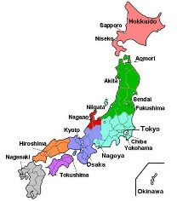

1. What island of Japan are you writing about?
2. What is the temperature and climate of the island you chose?
3. What does the landscape of this island look like—are there mountains, forests, rivers, flat farmland, etc.?
4. What types of plants can you find on this island? List at least two to three types.
5. What types of animals can you find on this island? List at least two to three types.
6. What makes this island important or special to the rest of Japan?

**Research Note Catcher** 

|  |  |  |
| --- | --- | --- |
| **Directions: Write**/Draw/make bullet note lists, of the interesting details about your habitat in these boxes! | 1. Name of island | 1. Plant Life |
| 3. Animal Life | 4. Climate and Temperature | 5. Importance of island to Japan |