|  |
| --- |
|  |
| Habitat/Ecosystem Diorama  Kenya |
| |  |  |  | | --- | --- | --- | | 1st Grade | [Date] | International Studies Project Q1 | |

Habitat Diorama Due Date: **Friday, September 26, 2025**

Directions

Our International Studies Program has begun! This year your child will be learning about Kenya. Most of this research will take place at school, but we have included resources you can use for research with your student at home! Please see below!

Each student will create a diorama (a scenic representation in which sculpted figures and lifelike details are displayed) showing a selected habitat from Kenya.

Students will choose one of the Kenyan habitats below to recreate in their diorama at home:

**The Savanna**

**Highlands- Mountains (focus on one of the options below)**

* Mount Kenya
* Mount Kilimanjaro
* The Great Rift Valley (focus on the entire valley ecosystem as a whole-including multiple mountains) *

To create the diorama, a shoe box or other small box may be used. The box should not be bigger than an adult sized shoe box. Students may use plastic figures or mold items from clay to represent animals, plants, and objects in their projects. Materials such as magazines (for photos), plants, popsicle sticks, toothpicks, construction paper, and other craft items may be used. Creativity is encouraged! Please see the examples on the following page!

**1st Grade Parent Acknowledgement Form**

I have seen and read the project description, and I am aware that the project is due on **Friday, September 26, 2025. Please return this form by August 29, 2025.**

___________________________________ _____________________

Student Name Date

___________________________________ ______________________

Student Name Date

**Examples of Diorama Habitats**

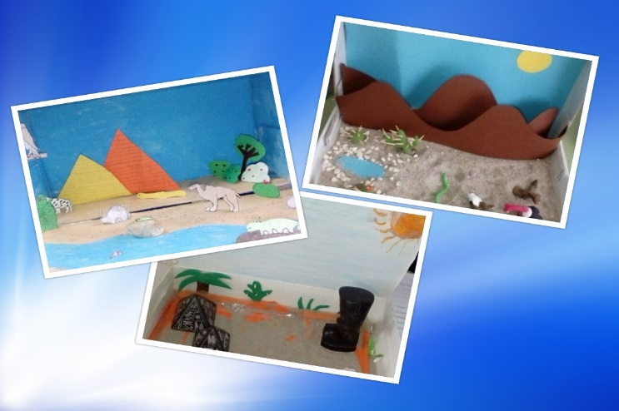

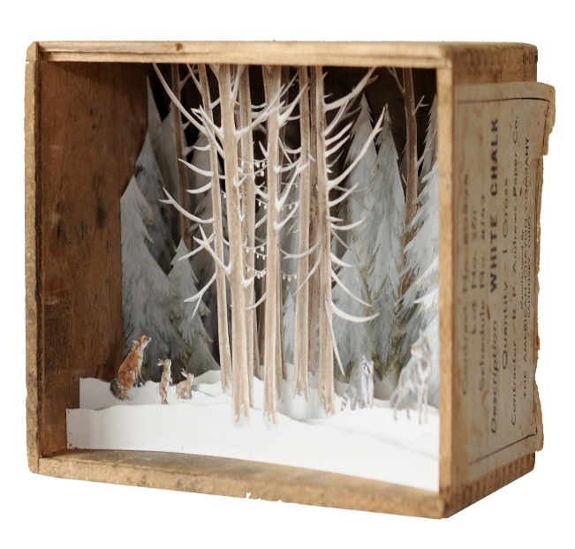

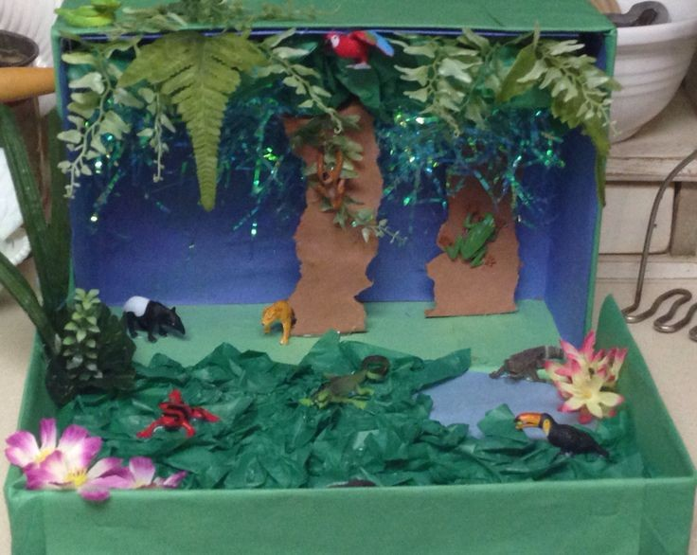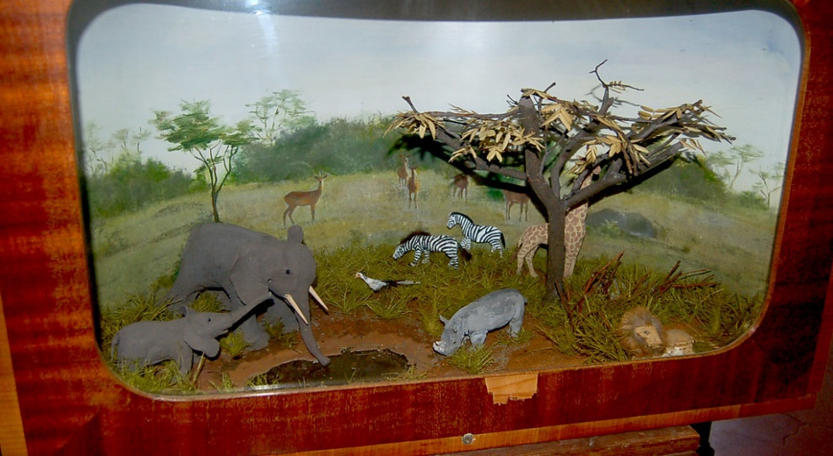

**Research Resources to Use at Home!**

**Savannah**

[National Geographic Kids Savannah Habitat Description](https://www.natgeokids.com/uk/home-is-good/savannah-habitat/)

[Facts about the World's Savannahs](https://www.twinkl.com/teaching-wiki/savannah)

**Highlands- Mt. Kenya**

[Encyclopedia Britannica Kids Mt. Kenya Description](https://kids.britannica.com/students/article/Mount-Kenya/328170)

[Pictures of Mt. Kenya](https://www.youtube.com/watch?v=iLuvSzTefJY)

**Highlands-Mt. Kilimanjaro**

[Picture and Fast Facts about Mt. Kilimanjaro (halfway down the page)](https://www.twinkl.com.kw/teaching-wiki/africa)

[Lonely Planet Mt. Kilimanjaro](https://www.lonelyplanet.com/tanzania/northern-tanzania/attractions/mt-kilimanjaro-national-park/a/poi-sig/1497459/1331832)

**Highlands-Great Rift Valley**

[Encyclopedia Britannica Kids Great Rift Valley Description](https://kids.britannica.com/students/article/Great-Rift-Valley/274642)

[National Geographic Rift Valley Articles (facts about Great Rift Valley included)](https://education.nationalgeographic.org/resource/rift-valley/)

**Student Checklist**

In your diorama you should include all of the following:

(Please check off all the items as you complete your project).

* Cover the inside of your box with paper. The color of the paper should reflect the habitat that you chose. For example, a forest would have a green background to represent the trees there.
* Write your name and the habitat you chose **on the side of your box.**
* Show at least two animals that live in this habitat.
* Show at least two plants that live in this habitat.
* Label the items you have placed in your habitat.

**Writing Piece (to be completed both at home and at school):**  
Describe what you have learned about your habitat in complete sentences by answering the questions below on separate index cards. On the front of each card, write your name and the question. On the back, write three to four complete sentences to answer the question.

* **Card 1:** Where in Kenya is this habitat?
* **Card 2:** What is the climate (normal weather) in this habitat like?
* **Card 3:** What plants and animals live in this habitat?
* **Card 4:** What makes this habitat important or special?

**After completing the project, you will present what you learned to your classmates. Be ready to describe your habitat and share facts about it!**

**Kenya Ecosystem Research Page!**

**Directions:** Keep this page at school and write down all the new things you learn about Kenya in it!

|  |  |  |
| --- | --- | --- |
| Facts about the Land (what it looks like/what  is the weather like?) | Facts about the Animals | Facts about the plants |

**Habitat Diorama Project Rubric**

|  |  |  |  |  |
| --- | --- | --- | --- | --- |
| Category | 1 | 2 | 3 | 4 |
| Habitat | The environment of the diorama does not relate to the chosen habitat.  Ex. A forest was picked but the box shows an ocean. | The environment is not different than what is stated on the box, but none of the features of the chosen environment are present.  Ex. The box has blue paper for the ocean but nothing representing water inside. | The environment matches what is on the box and displays 2-3 major features of the chosen environment.  Ex. The Savana is shown to have grass and lions but may not show any plants from that region. | The environment matches what is listed on the box and displays all major features. |
| Plants | There is no evidence of plants in the diorama. | Plants from the habitat are present but not labeled. | The diorama has at least one plant from the habitat that is labeled. | The diorama has two types of plants that are labeled. |
| Animals | There is no evidence of animals in the diorama. | Animals from the habitat are present but not labeled. | The diorama has at least one animal from the habitat that is labeled. | The diorama has two animals that are labeled. |
| Written Explanation | No written explanation was provided. | The student did not answer all of the questions given or may not have used complete sentences for all of them. | The student answered every question given but did not use complete sentences for 1 or 2 of them. | The student answered every question given in 2-3 complete sentences on index cards. |
| Creativity and Neatness | The diorama is not organized, and the items are not securely attached to the box. | The diorama Is somewhat organized. Some items are securely attached to the box. | The diorama is attractive and well organized. Everything is secured to the box. | The diorama is attractive and well organized. Everything is secured to the box. |
| Presentation to Class | Student was not able to describe habitat in complete sentences to class. | Student shared one to two details about habitat but did not use complete sentences throughout presentation. | Student shared all major details about habitat (plant, animals, location) using complete sentences. | Student shared major details about habitat (in addition to giving extra facts found from their research) in complete sentences. |

**Student Name: _____________________________________ Score ________/24**