Recorder FAQs
4th & 5th Grade
What recorder should I purchase?
Your student needs a Soprano Recorder using the Baroque Fingerings. If it says German do not buy it. The German style recorders use a different fingering for the notes than the Baroque style recorder that we use in class. In the following questions I have given options for brands, pricing, and websites for ordering.
Where can I purchase a recorder?
There are many places you can order a recorder, but these are some of my choice sites as I look to see which one I can get free shipping. See the brand recommendations and typical costs bellow.
www.westmusic.com
www.amazon.com
www.musiciansfriend.com
www.target.com
www.walmart.com
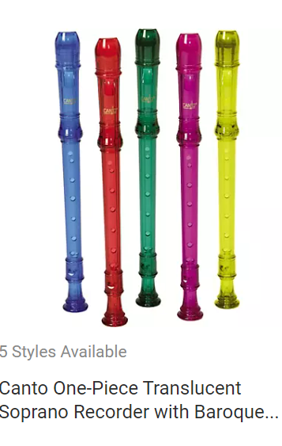
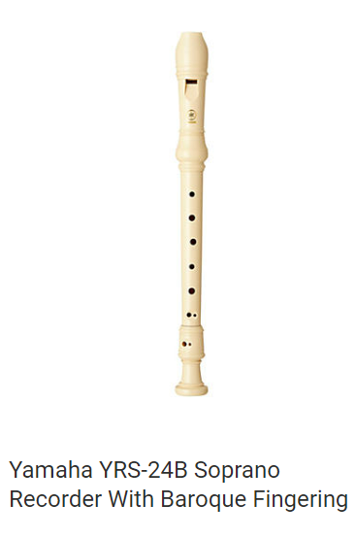
What are some of the best brands?

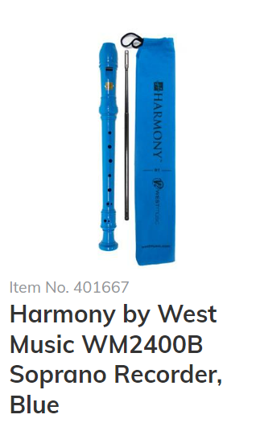
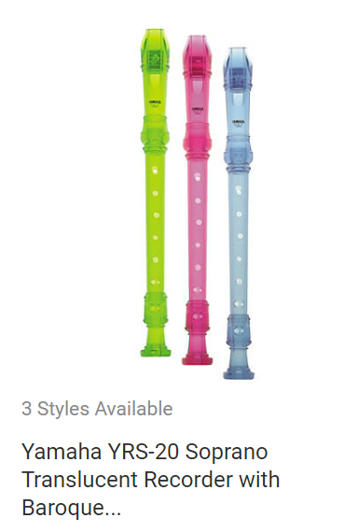
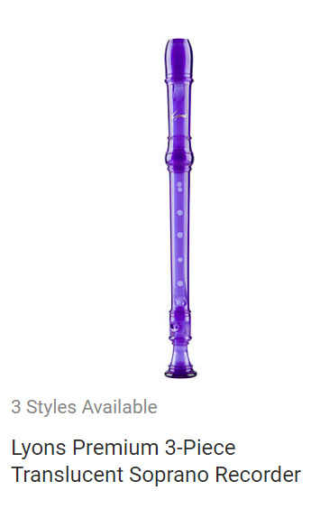

How much should a recorder cost?
Yamaha YRS-24B Soprano $9.99
Canto One-piece Translucent Soprano $6-$9
Yamaha YRS-20 Translucent Color $5.69-$9.99
Lyons Premium 3-piece Soprano $3.99-$5
Harmony by West Music $3.39 + shipping

