**Topic: Thomas O. Fuller**

-born in Franklinton, North Carolina on October 25, 1867

-graduated from Shaw University with a B.A. degree in 1890 and a master’s degree in 1893

-was a Baptist minister

-was elected to the North Carolina state senate in 1898

-moved to Memphis in 1900 to become minister of the First Colored Baptist Church.

-in 1902 became the principal of Howe Institute (a historic Black school in Memphis)

-one of the first members of the NAACP chapter established in Memphis

-helped establish a Memphis chapter of the Commission on Interracial Cooperation (CIC)

-published books and articles including an autobiography, *Twenty Years in Public Life, 1890-1910*

-Memphis public parked named after him

**Thomas O. Fuller**

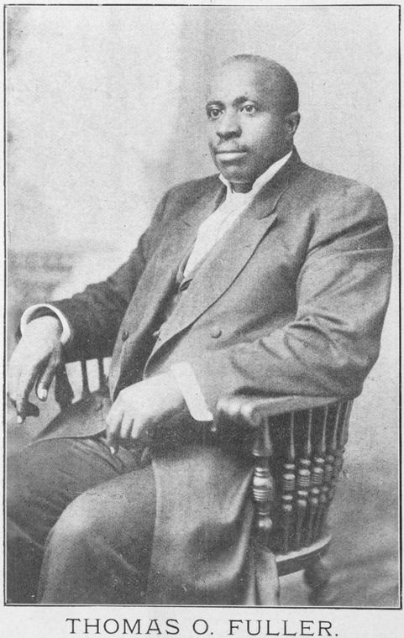

Thomas O. Fuller contributed to Black history in many ways. He was born in Franklinton, North Carolina in 1867. Later, he attended Shaw University where he received his B.A. degree in 1890 and a master’s degree in 1893. In 1898, Fuller was elected to the North Carolina state senate. A Baptist minister, Fuller moved to Memphis in 1900 to become the minister of the First Colored Baptist Church. In 1902, he became the principal of the Howe Institute, a historic Black school in Memphis. Fuller helped establish Memphis chapters of the NAACP and the Commission on Interracial Cooperation (CIC). He published many papers including an autobiography called, *Twenty Years in Public Life, 1890-1910*. Thomas O. Fuller left such an important mark in Memphis that there is a public park named in his honor!