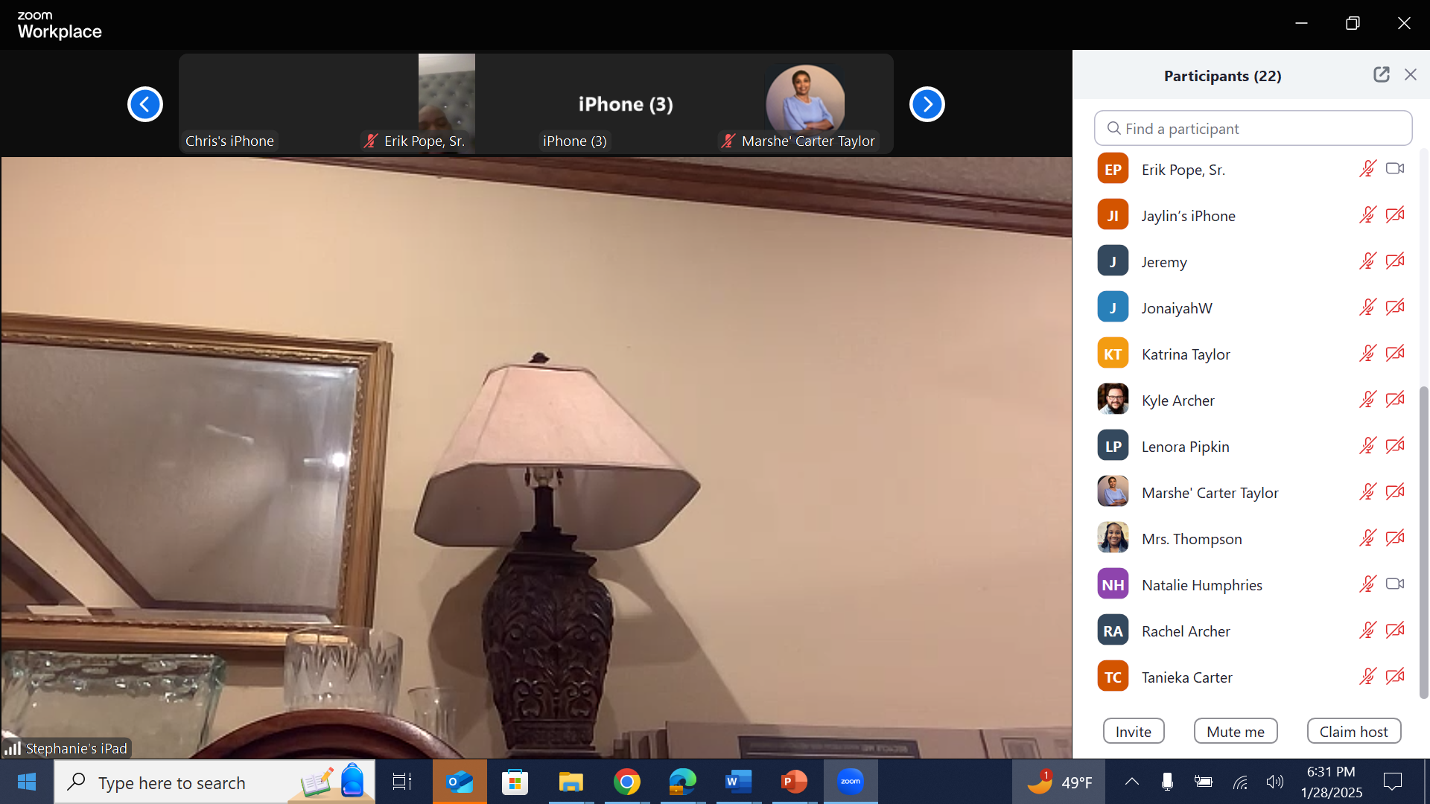Parent Meeting January 28 630 pm

