3rd Grade International Studies Project Quarter 1:

Ecosystems/Habitats of Mexico

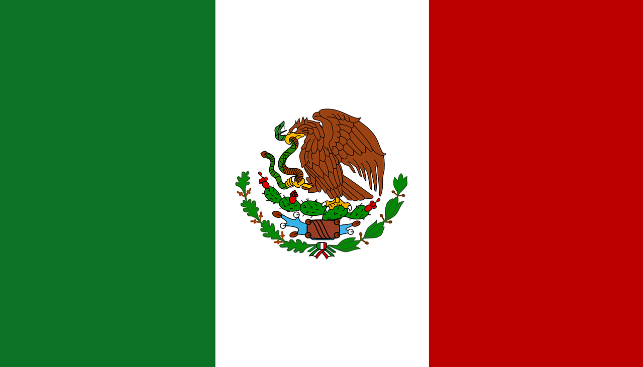

Please have fun with this project. Learn as many unique facts as you can about your chosen ecosystem and its role in Mexico. You may use any of the materials listed below and more! The project and the paragraph(s) are due on:

**Friday, September 26, 2025**

**Directions**

**Project Due Date** **Friday, September 26, 2025**

Our International Studies curriculum has begun! This year your student is learning about the nation of Mexico. For their Quarter One International Studies Project they will research and learn about the different ecosystems within Mexico. Most of their research will take place at school, but there is a list of suggested websites to go to for research at home included in this packet. They will choose one of these ecosystems they’ve studied to recreate in a shoebox. Students will also write about the environment they’ve studied.

You must choose to make **one** of the following ecosystems:

1. **Mountain Ranges (focus on one of the options below)**

* Sierra Madre
* Sierra del Sur

1. **Deserts (focus on one of the options below)**

* Chihuahuan Desert
* Gran Desierto de Altar
* Yuma Desert

1. **Rainforests**

You must write at least one to two detailed paragraphs about the ecosystem you chose. You will begin this step with the teacher in class and then complete it at home. Use the “**Five Questions Worksheet”** on the back of this page to help you find the details to include in your paragraph(s). You must turn in one to two neatly written or typed paragraphs with your shoebox; your paragraph(s) should contain the answers to the **“Five Questions Worksheet” and extra details** you gathered during your research. You will read your writing when you present your project to the class. **Don’t forget to add an interesting title and to indent your paragraphs!**

**Required Materials- Must be turned in with your project**

* Shoebox (or some small box-should not be bigger than an adult sized shoebox)
* Your name and grade section on the lid of the box or the back of the box.
* The name of the ecosystem/habitat you chose on the side of your box.
* Paper covering the back of your box that is colored to represent your environment (e.g., green paper for forests, brown paper for deserts, etc.)
* 2-3 Animals that live in the habitat (can be made of clay, drawn, or bought). Include a label with their names.
* 2-3 Plants that live in the habitat (can be made of clay, drawn, or bought). Include a label with their names.

**\*\*Optional Materials**- Can be added to project to make it creative

* Real vegetation
* Sand, soil/dirt, contained bodies of water
* Rocks
* Clay models of landmarks such as mountains, volcanoes, trees, etc.

**3rd Grade Parent Acknowledgement Statement**

Please read and sign the statement below and return it to your child’s homeroom teacher no later than **Friday, August 29, 2025**.

I have read the directions and project description above in their entirety. I understand that the required materials listed above, and a writing piece of at least one to two paragraphs is due on

**Friday, September 26, 2025.**

______________________________________ _______________

Parent Signature Date

_____________________________________ _______________

Student Signature Date

**Project Timeline**

|  |  |
| --- | --- |
| **Task** | **Due Date** |
| **Turn in “Five Questions” worksheet(s) to your teacher.** | **September 5, 2025** |
| **Turn in the writing portion using the worksheet to help guide your thoughts to your teacher.** | **September 15, 2025** |
| **Turn in your chosen ecosystem within Mexico (shoebox) to your teacher.** | **September 26, 2025** |

Suggested Websites for Research at Home

Directions: These websites are meant to be used as a resource for researching the ecosystem your student is studying at home. This is not meant to be a complete list; rather, it should serve as a starting point for any research you would like to do with your student at home!

[National Geographic Kids Website](https://kids.nationalgeographic.com/)

[Encyclopedia Britannica Kids Website](https://kids.britannica.com/)

[Lonely Planet Kids Website](https://www.lonelyplanet.com/kids)

[Time Magazine For Kids](https://www.timeforkids.com/k1/?age=child)

**Examples of Ecosystems in a Shoebox Projects**

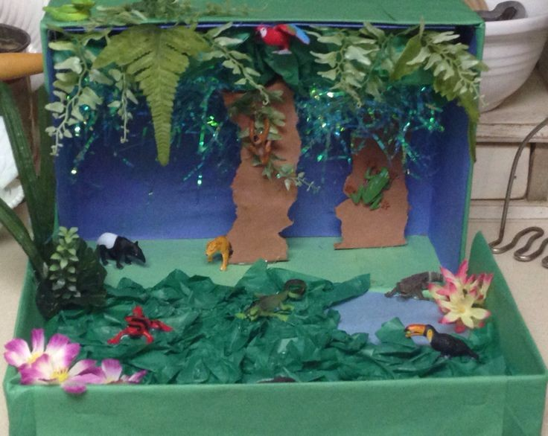 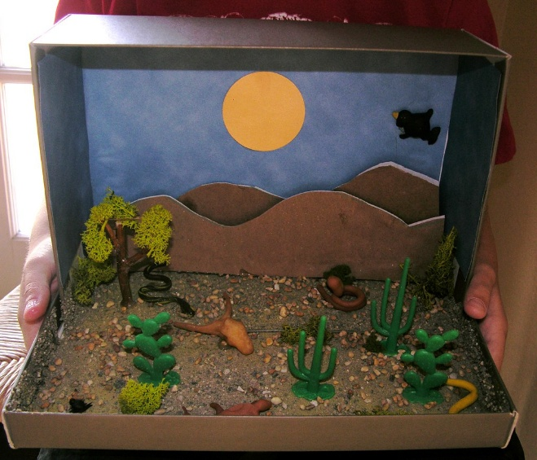

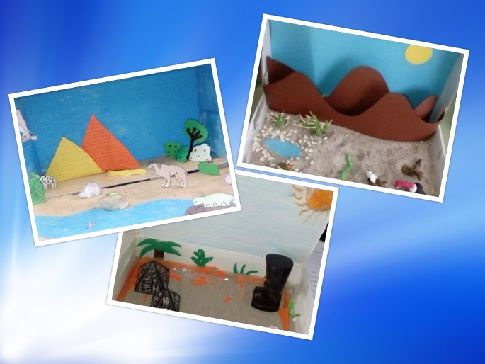 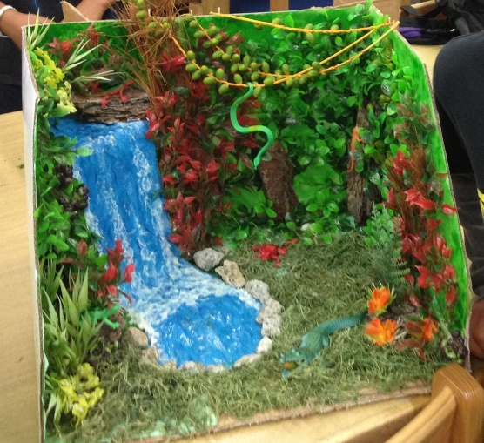

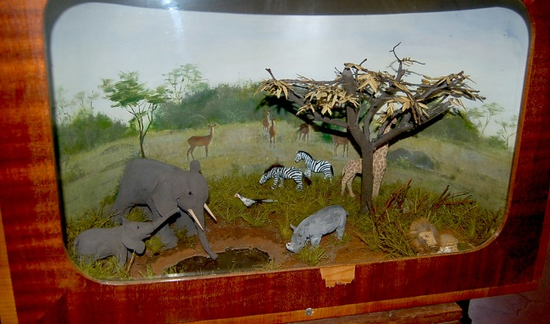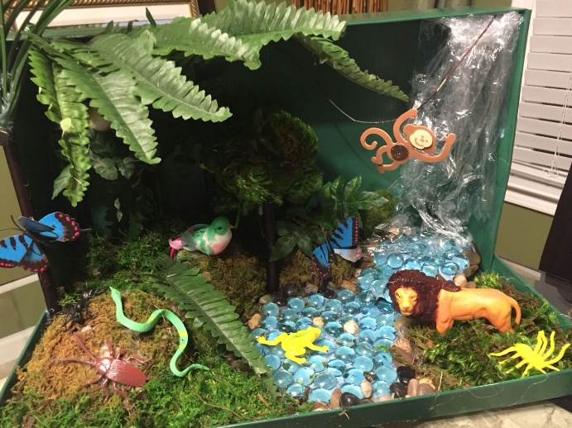

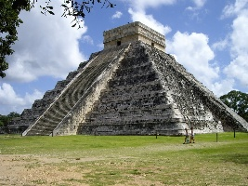  **Five Questions Worksheet** 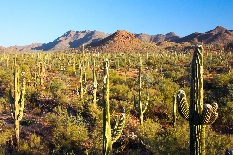

**Directions: Record your answers to the five research questions given below.**

|  |  |  |  |  |
| --- | --- | --- | --- | --- |
| **1. Where in Mexico is your habitat/ ecosystem located?** | **2.What animals can be found in your ecosystem?** | **3. What plants can be found in your ecosystem?** | **4. What is the temperature and climate of this habitat?** | **5.Why is this habitat important? / How does this habitat help Mexico?** |
|  |  |  |  |  |

**Next Steps due by September 15, 2025.**

Once you have answered the questions, use the details from this worksheet to write (or type) **at least one to two paragraphs about your ecosystem.** Your writing should have a title that is related to the ecosystem you chose and gives the reader an idea of what they’ll be reading about. Each paragraph you write should contain 5-7 complete sentences and should be well organized; this means you need to finish giving all the details you want to include about a particular part of your habitat (like the animals that can be found there) before you move onto talking about another part of your habitat.

|  |  |  |
| --- | --- | --- |
| **Directions: Write**/Draw/make bullet note lists of the **interesting details** about your habitat in these boxes! | 1. Location of Habitat | 1. Plant Life |
| 3. Animal Life | 4. Climate and Temperature | 5. Importance of habitat to Mexico |

**Ecosystem in a Box Project Rubric**

|  |  |  |  |  |
| --- | --- | --- | --- | --- |
| **Category** | **1** | **2** | **3** | **4** |
| Habitat | The environment of the diorama does not relate to the chosen habitat.  Ex. A forest was picked but the box shows an ocean. | The environment is not different than what is stated on the box, but none of the features of the chosen environment are present.  Ex. The box has blue paper for the ocean but nothing representing water inside. | The environment matches what is on the box and displays 2-3 major features of the chosen environment.  Ex. The Savana is shown to have grass and lions but may not show any plants from that region. | The environment matches what is listed on the box and displays all major features. |
| Plants | There is no evidence of plants in the diorama. | Plants from the habitat are present but not labeled. | The diorama has at least one plant from the habitat that is labeled. | The diorama has two types of plants that are labeled. |
| Animals | There is no evidence of animals in the diorama. | Animals from the habitat are present but not labeled. | The diorama has at least one animal from the habitat that is labeled. | The diorama has two animals that are labeled. |
| Written Explanation | No written explanation was provided. | The student turned in one paragraph, but it was not complete-was not 5-7 sentences and did not answer all of the questions on the five questions worksheet. | The student turned in one to two paragraphs that answered all of the questions on the five-question worksheet; however, the paragraphs are not well organized/  focused. | The student turned in one to two organized and focused paragraphs that answered all of the questions on the five-question worksheet. |
| Creativity and Neatness | The diorama is not organized, and the items are not securely attached to the box. | The diorama Is somewhat organized. Some items are securely attached to the box. | The diorama is attractive and well organized. Everything is secured to the box. | The diorama is attractive and well organized. Everything is secured to the box. |
| Presentation to Class | Student was not able to describe habitat in complete sentences to class. | Student shared one to two details about habitat, but their presentation was not focused; the facts shared were unrelated to what was in the box/ project. | Student shared all major details about habitat in their box (plant, animals, location) using complete sentences. They remained focused on these facts throughout. | Student shared major details about habitat (in addition to giving extra facts found from their research) in complete sentences.  They remained focused on these facts throughout. |

**Student Name: ______________________ Score_______/24**