Southwind HS

Scholarship & Career Opportunities Update
February 23, 2021 Edition

- Cameron William Selmon Scholarship
NOTE: Cameron Selmon was a former SOUTHWIND HS STUDENT! Last year, we had a winner of this scholarship from Southwind HS and would like to have another winner again this year!
In the spirit of remembering Cameron's life and helping our youth accomplish their dreams, Justice For Cameron Inc. is pleased to offer the Cameron William Selmon Scholarship for seniors in the graduating class of 2021. Please visit www.justiceforcameron.com for more information about Cameron, JFC Inc, the scholarship, and ways you can help support the scholarship fund through donations. Thank you! ❤️🎓 #share #CameronWilliamSelmonScholarship #ClassOf2021
Please share with eligible students
ELIGIBILITY CRITERIA
- Complete Application (assessable via www.justiceforcameron.com – application deadline is March 15, 2021)
- High School Senior: Residing in Shelby County (TN)
- GPA: 2.5 Minimum (transcript excluding SSN’s to be uploaded to the online application)
- College Acceptance Letter (to be uploaded to the online application)
- Essay: Please share your thoughts on gun violence, and how it has become an epidemic in our city. How can you become a champion and take a stand against gun violence? (minimum of 500 words- to be uploaded to the online application)

Link for the video:
https://vimeo.com/412915305
https://justiceforcameron.com/recipients/

Silence the Violence Through the Arts Contest:
https://justiceforcameron.com/art-contestants/

- Curtis L. Johnson Scholarship Foundation

The Curtis L. Johnson Scholarship Foundation is pleased to announce the 5th Annual Curtis L. Johnson Memorial Scholarship. This scholarship was established to assist high school students in the Shelby County area continue their education while honoring the life and memory of Curtis L. Johnson. Please share this opportunity and encourage high school seniors to apply. Please note there is a mistake on the flyer. This scholarship is open to all college majors, not just Computer Science.

Student can apply at www.curtisjohnsonscholarship.org

Application Window: January 15 through March 31, 2021
Scholarship Amount: $1,000
Number of Scholarships: Five (5)

- University of Memphis First Scholars Program (U of Memphis applicants ONLY)

There are still scholarships available for qualifying students for the University of Memphis First Scholars Program. Attached are flyers in both English and in Spanish outlining details to share with interested students.
Students can apply for up to $20k in scholarships ($5k per school year) through the First Scholars Program - the deadline is February 1, 2021. Please connect with Mrs. Rodriguez should there be program specific questions.
Jaclyn Savell Rodriguez
Program Coordinator
jpsavell@memphis.edu

- City of Memphis Blue Pathway Program (Police Officers in Training)
Many of you have welcomed us in the past few years and the City of Memphis has had the privilege of hiring many of your graduates into the Memphis Police Department’s Blue Path Program. Now more than ever, it's imperative that the students of our city are prepared to take on life after graduation and are knowledgeable of all their career options!

This is an awesome opportunity for high school seniors interested in a career in law enforcement that provides benefits that are unmatched by any other police department including, but not limited to:

- Salary of $33,500+ per year or $16.12 per hour
- Free Degree in Criminal Justice from Southwest Tennessee Community College
- Health Benefits
- Begin a Career in Criminal Justice learning $41,800+ per year (at the age of 21 and after successful completion of 54 semester credit hours)

Working as a Memphis Police Officer will push them to learn real leadership, take on great responsibility, and reach their full potential all while making a difference in the City of Memphis. The Blue Path Program is the start of a rewarding career and we would love to meet with your students to give them more information about this opportunity. We have engaging presentations with actual Police Service Technicians (PSTs) and Memphis Police Officers to give real-life examples and insights.

- Community Foundation for a Greater Memphis Scholarships

Community Foundation for a Greater Memphis
Application Link: www.cfgm.org/scholarships
Application Deadline: Thursday, April 1, 2021, at 4:00 pm
Please direct all questions to Vanessa Langston at vlangston@cfgm.org or
(901) 722-0032

- LaToya S. Cameron Memorial Scholarship

As you already know, LaToya S. Cameron was a long-time school counselor and former teacher at Cordova High School. A scholarship in the amount of $1000 has been created in her memory.
Scholarship Amount: $1000
Application Link: https://www.lscfdn.org/application
Application Deadline: April 5, 2021

- Riding Forward to a Better Future
High school seniors in the 15 states that have Regions branches may submit a story about a Black American who has served as an inspiration. That essay can then lead to a $5,000 college scholarship.
Here’s how the contest works:
- Through March 31, high school seniors are encouraged to submit 500-word essays honoring a Black American who has been an inspiration in the applicant’s life.
- Essays will be judged by an independent panel, with winners announced by Regions later this summer. Winning essays will also be published on regions.com.
- Scholarships will include a total of 15 awards of $5,000 each for high school winners.
- One high school winner and one college winner will be selected from each of the 15 states served by Regions branches.
Information, rules and entry forms more can be found on www.regions.com/ridingforward.

- The Merchant Marines
The Merchant Marines is an excellent source of Commissioning and future Maritime Careers
https://www.usmma.edu/admissions

- American Association of Blacks in Energy Scholarship
*Due March 7, 2021.
See the following LINK for the Scholarship Packet:
2021 Parent and Student Scholarship Handbook Memphis^J TN.docx

- Virtual Performing Arts Showcase for the Memphis Area
Link under picture below if interested! Due 2/28/2021 https://docs.google.com/document/u/0/d/1cWyJJ3xO7SJrYn2WjaVCM6TiSjiciKS_Mw-sOpBqNPk/mobilebasic

- 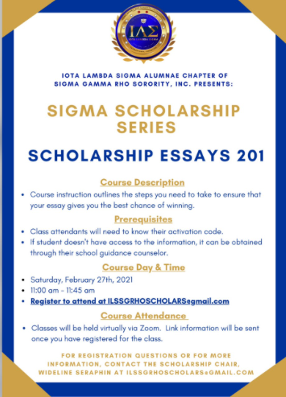

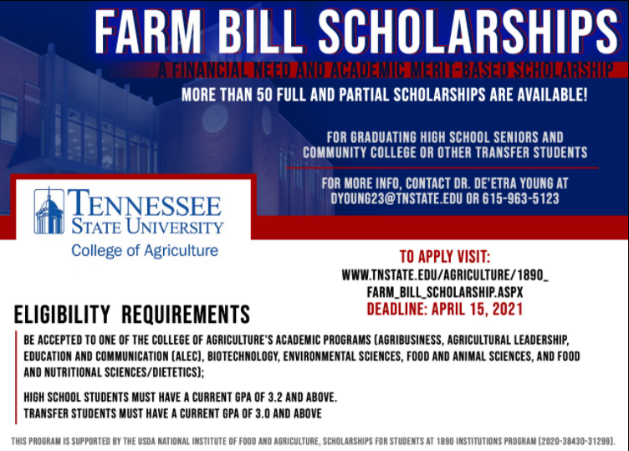

- 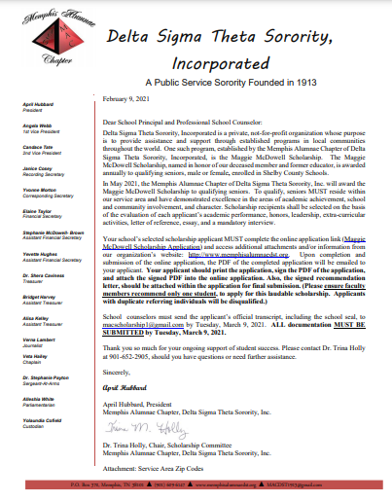
- 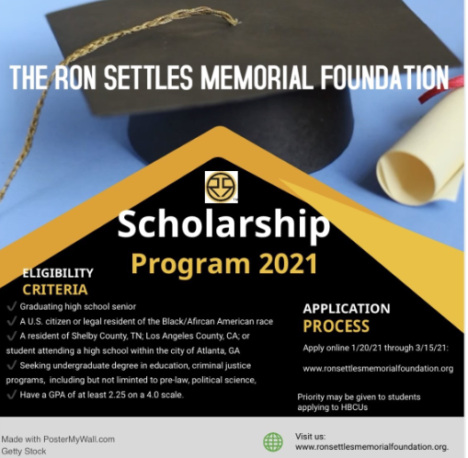

- ALPHA MEMPHIS EDUCATION FOUNDATION’S ANNUAL SCHOLARSHIP
FRATERNITY INVITES APPLICATIONS FROM MALE HIGH SCHOOL SENIORS

Memphis, TN (8 February 2021) – The Alpha Memphis Education Foundation – the educational arm of the Alpha Delta Lambda chapter of Alpha Phi Alpha Fraternity, Inc. – has officially opened its annual scholarship application for the 2020-2021 academic season. AMEF seeks graduating male high school seniors who have demonstrated academic excellence, and who will pursue collegiate education in the Fall of 2021. Completed applications must be received by 12 April 2021 for consideration, and can be accessed via Alpha Memphis Education website, https://www.alphamef.org/about/scholarship/2021-scholarship-application

