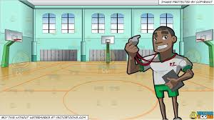 |  | SCHOOL LOGO

SPRINGDALE ELEMENTARY | PHYSICAL EDUCATION/HEALTH
PE/HEALTH |PRE-K-5| 2020-21 |

WELCOME PARENTS
My name is Coach Williams. I am your child’s Physical Education/Health teacher for this school year. This is my third year teaching at Springdale Elementary. This year we will learn many physical education skills such as: Locomotive movements, health and nutrition, and various sports activities. However, these skills will be taught using teams virtual learning.

I have reviewed this letter with your child, but please go over it again to reinforce my class rules and consequences. I need your help and support to make this a great school year. Feel free to contact me anytime. My planning periods are Tuesday-Thursday from 2:10-3:00. The telephone number to Springdale Elementary is (901)416-4883. I appreciate the oppportunity to work with you and your child.
 |  | 
Virtual Class Rules
- Arrive on time
- Keep camara on at all times
- Respect all people, things opinions and beliefs
- No gum, candy, food or drink

