Student Absence Form
This document explains how to access student absence forms that are submitted via PowerSchool Parent portal.
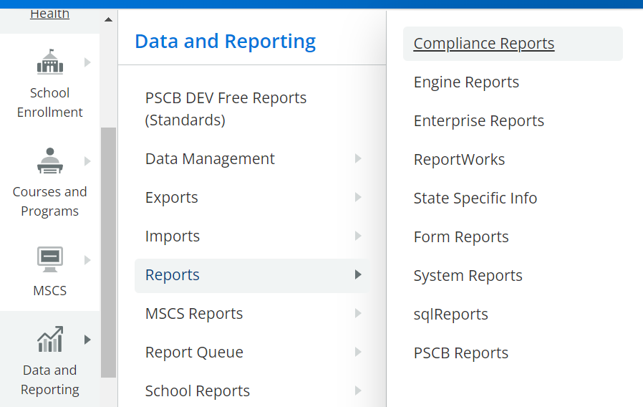
- From the Start Page, select Data and Reporting, Reports and then Form Reports.
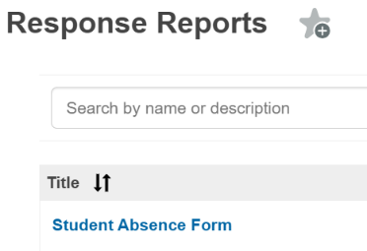
- One the Response Reports tab, select Student Absence Form.

- Click Generate Report to display any submitted forms.
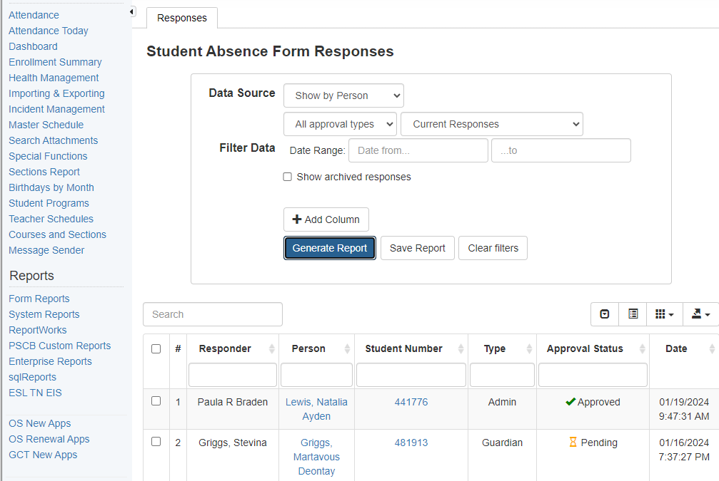

- Click the student number to open the absence form. Click OK at the warning to approve/reject the absence form.

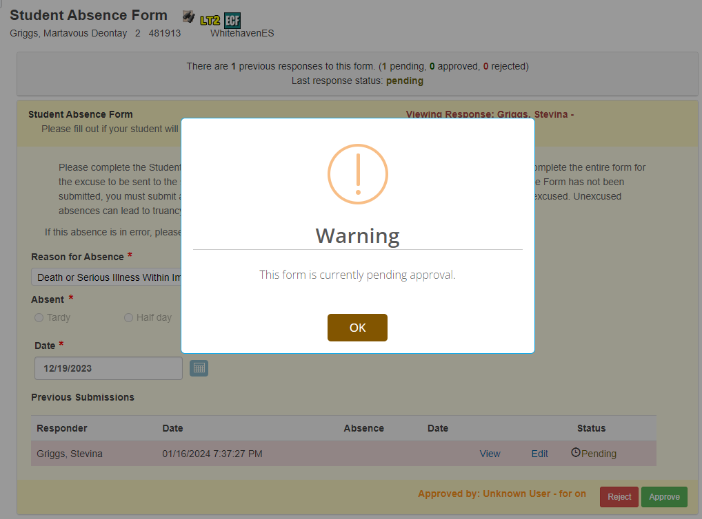

- Select approve/reject based on the Reason for Absence in accordance with our District’s policy.

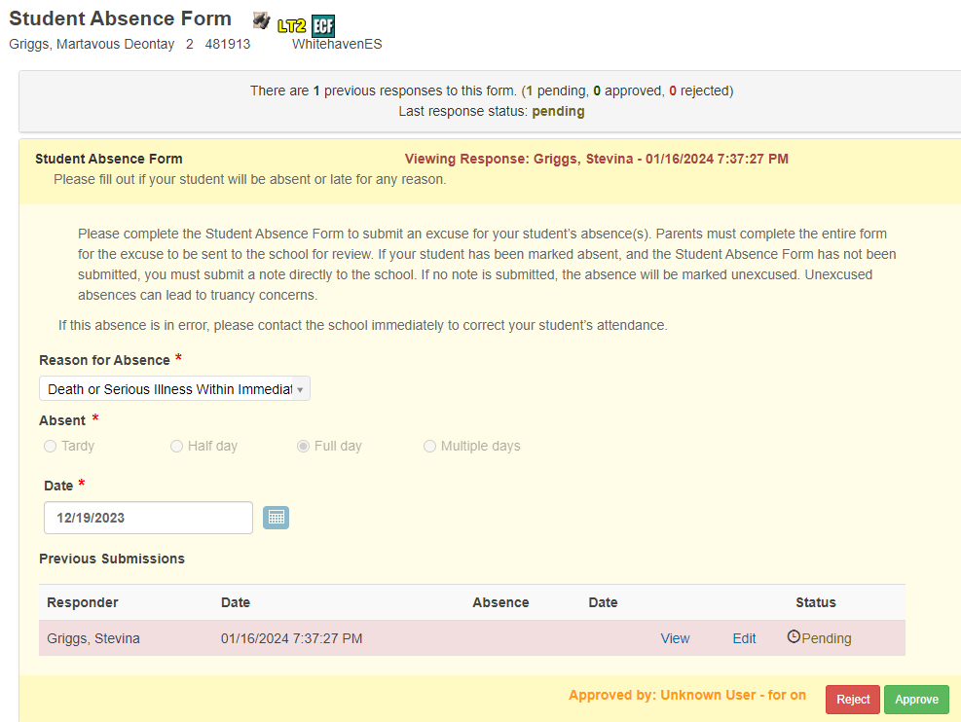

- If approve is selected, you must enter the password “aes” to approve and proceed.
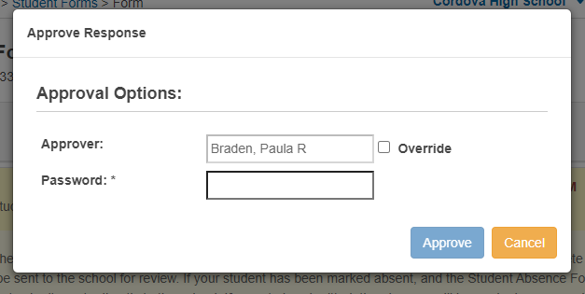

- If reject is selected, you must enter the password “aes” and the reason before proceeding.
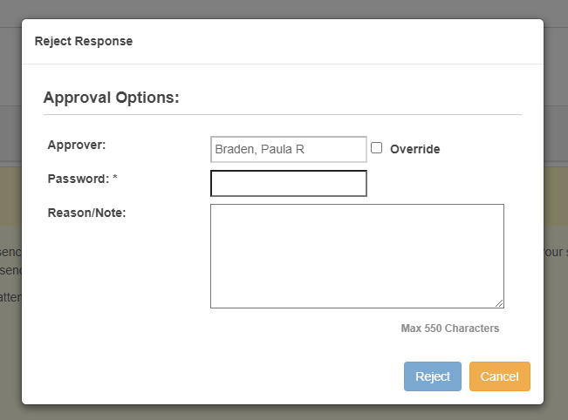
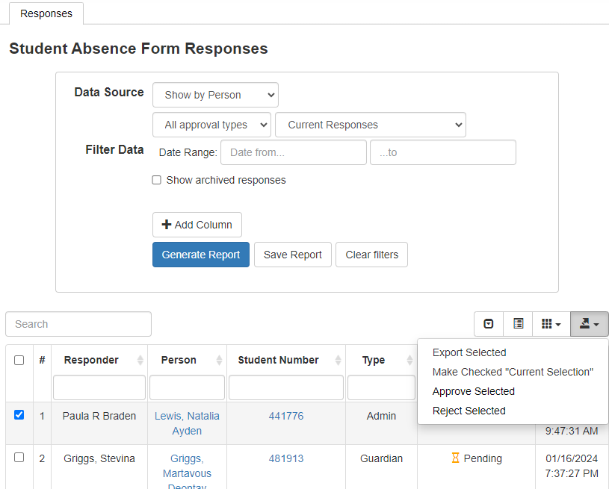
- You can select desired students from the generated report to make Current Selection to update the daily attendance code.

